# Mock Test – 1. ( part-3)

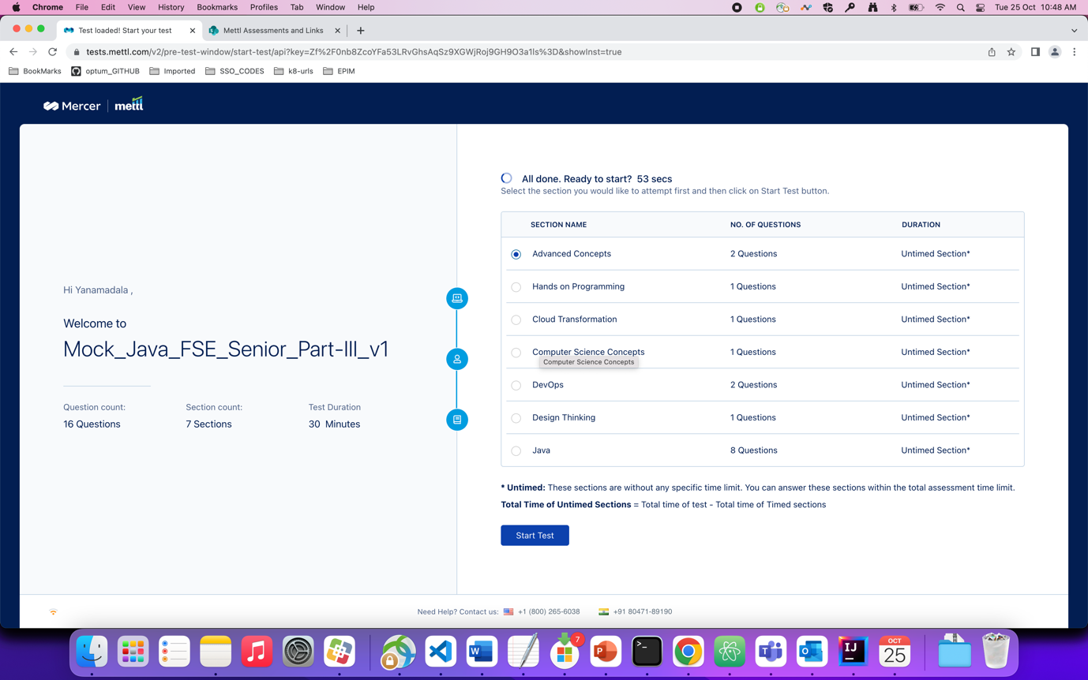

Question : which of the following statements are not true about service registry.

Ans : 1

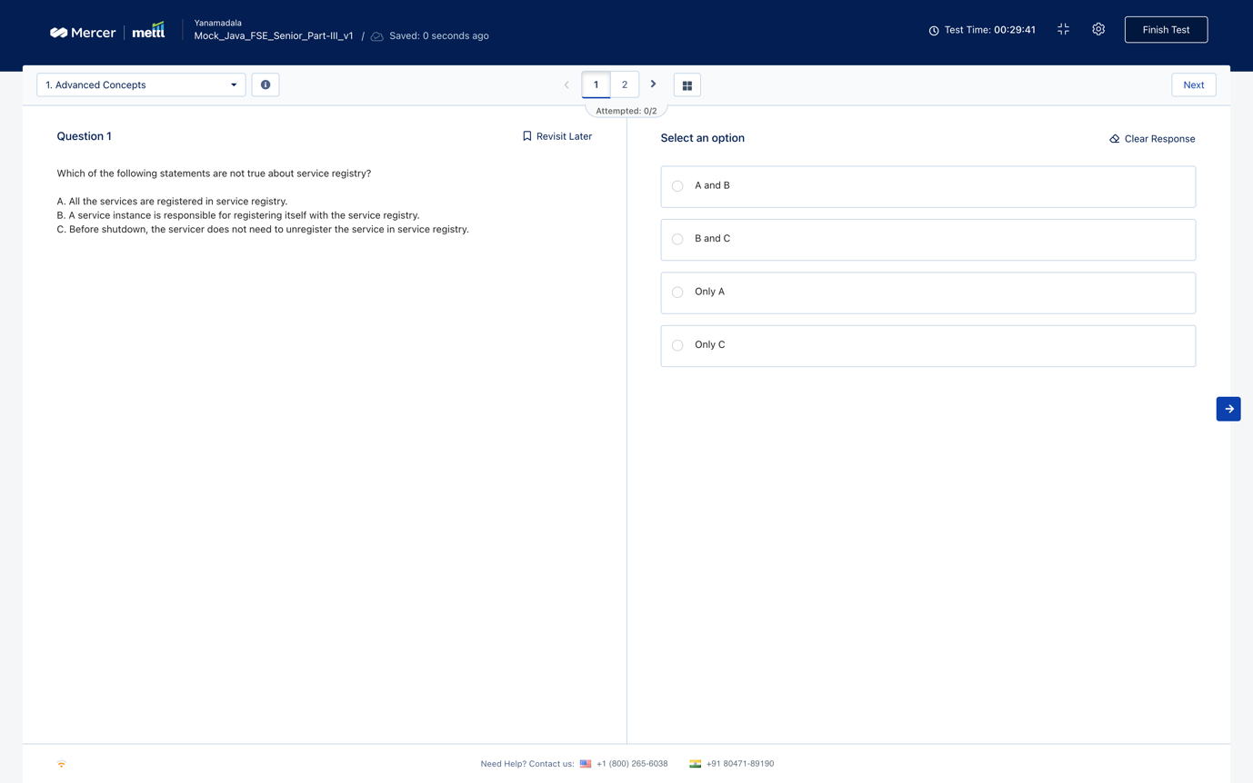

Question : you have 4 partitions and 4 brokers with replication factor as 2 with ability to override……

Ans : 1

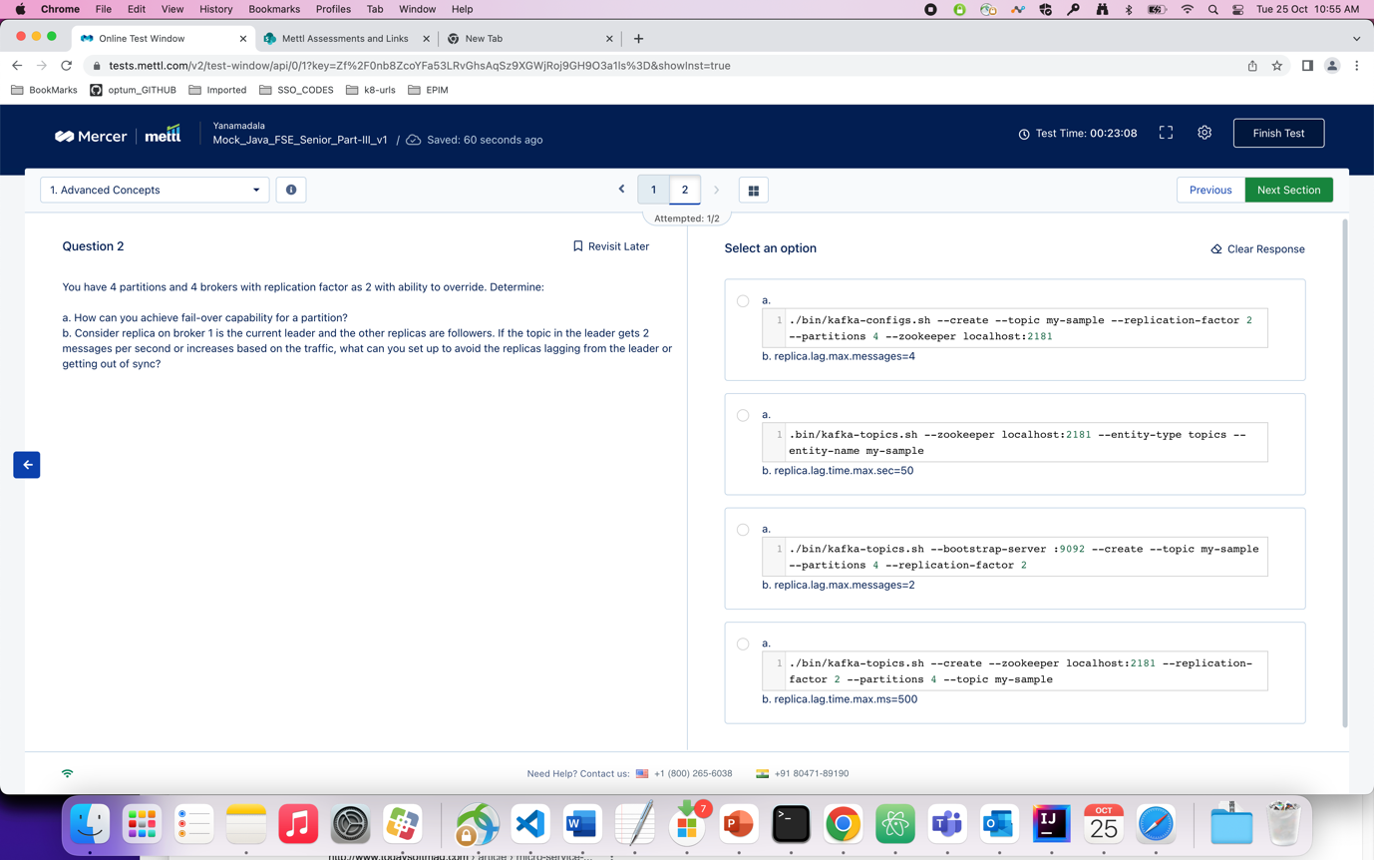

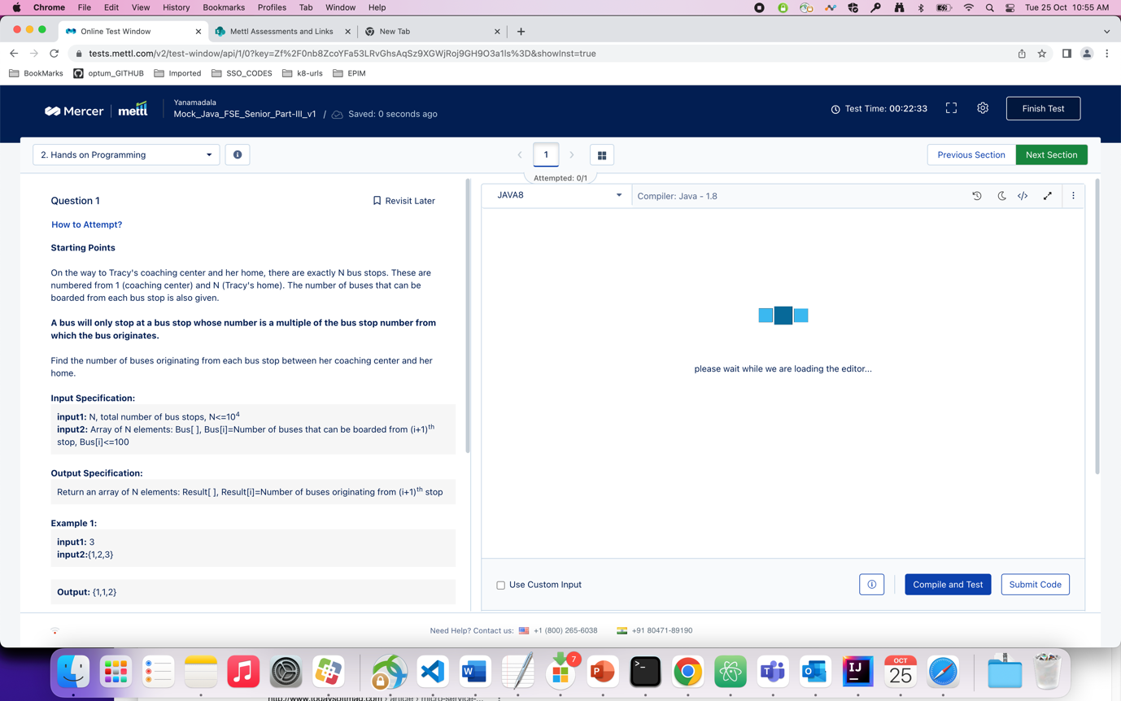

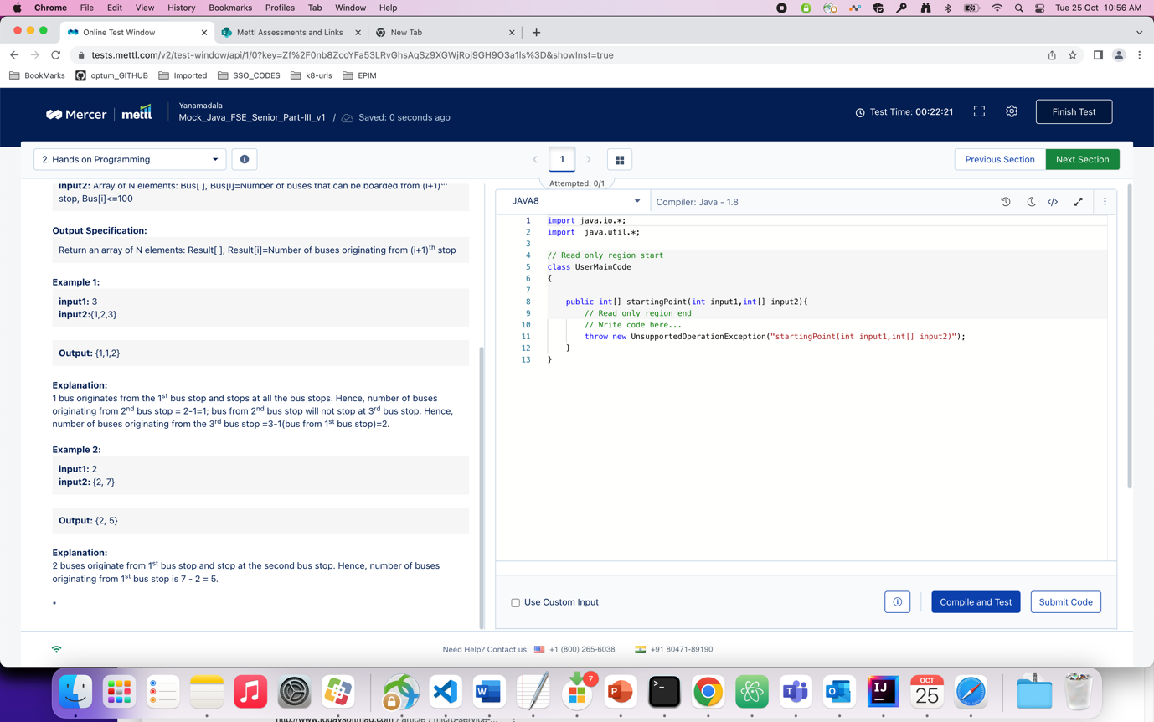

Ans : program

package com.optum.mdm.pmdmui.config;  
  
import java.util.Scanner;  
  
class Result  
{  
 int[] output1 = new int[10005];  
}  
  
public class Test {  
  
 public static void main(String[] args) {  
 // System.out.println(b1[0]);  
 Scanner s = new Scanner(System.*in*);  
 int n = s.nextInt();  
 int[] arr = new int[n];  
 for(int i=0;i<n;++i){  
 Scanner s1 = new Scanner(System.*in*);  
 arr[i] = s.nextInt();  
 }  
 Result ans;  
 ans = *startingPoint*(n,arr);  
 for(int j=0;j<n;j++){  
 System.*out*.println(ans.output1[j]);  
 }  
 }  
  
 static Result startingPoint(int input1, int input2[]){  
  
 int n = input1;  
 Result ans = new Result();  
 for(int j=1;j<=n;j++){  
 ans.output1[j-1] = input2[j-1];  
 for(int i=1;i<j;i++){  
 if(j%i == 0){  
 ans.output1[j-1] -= ans.output1[i-1];  
 }  
 }  
 }  
 return ans;  
 }  
  
}

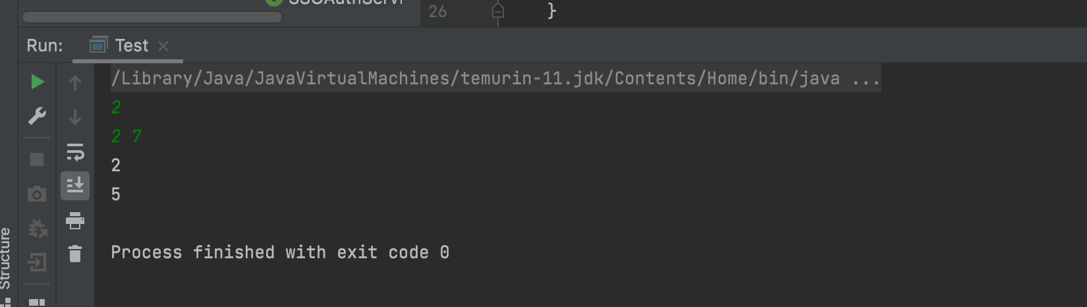

Question : which of the following is/are not prerequisite(s) for ACS ?

Ans : A

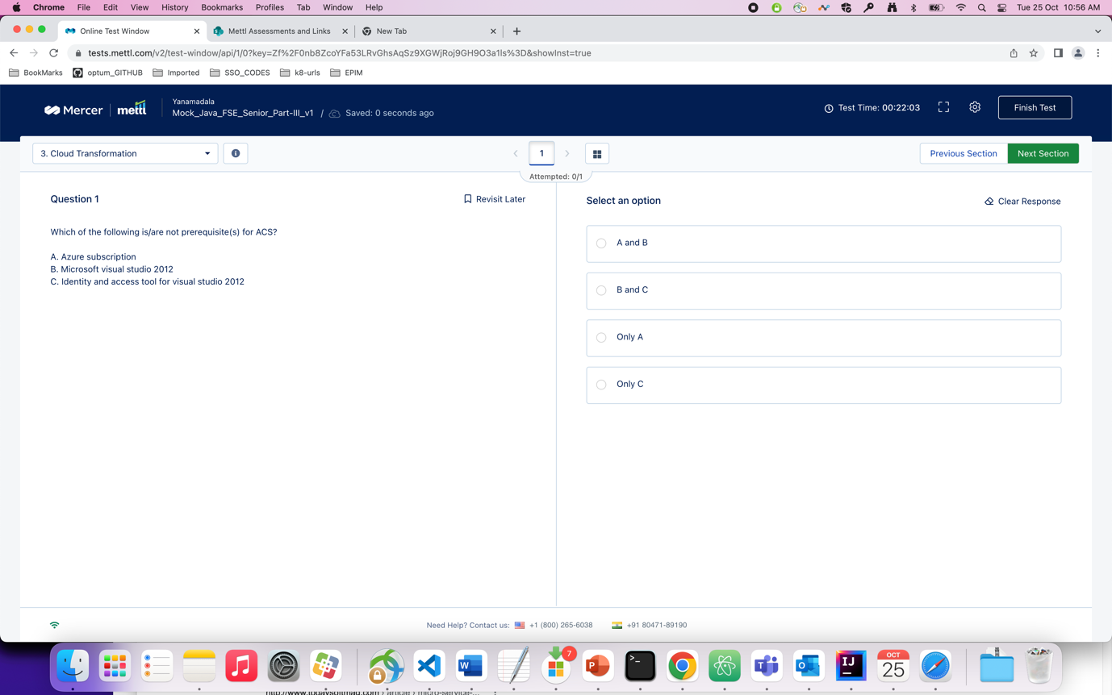

Question : which of the following statements is true in Data structure ?

Ans : 3

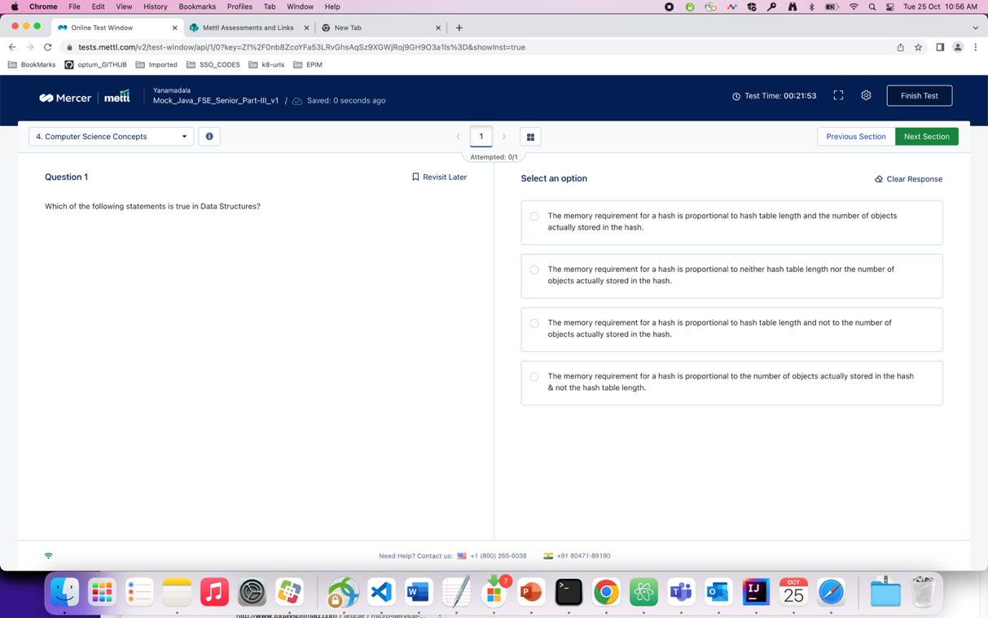

Question : you want to create a service called “myAppService” to enable the use of an application deployed….

Ans : 3. (subsets…)

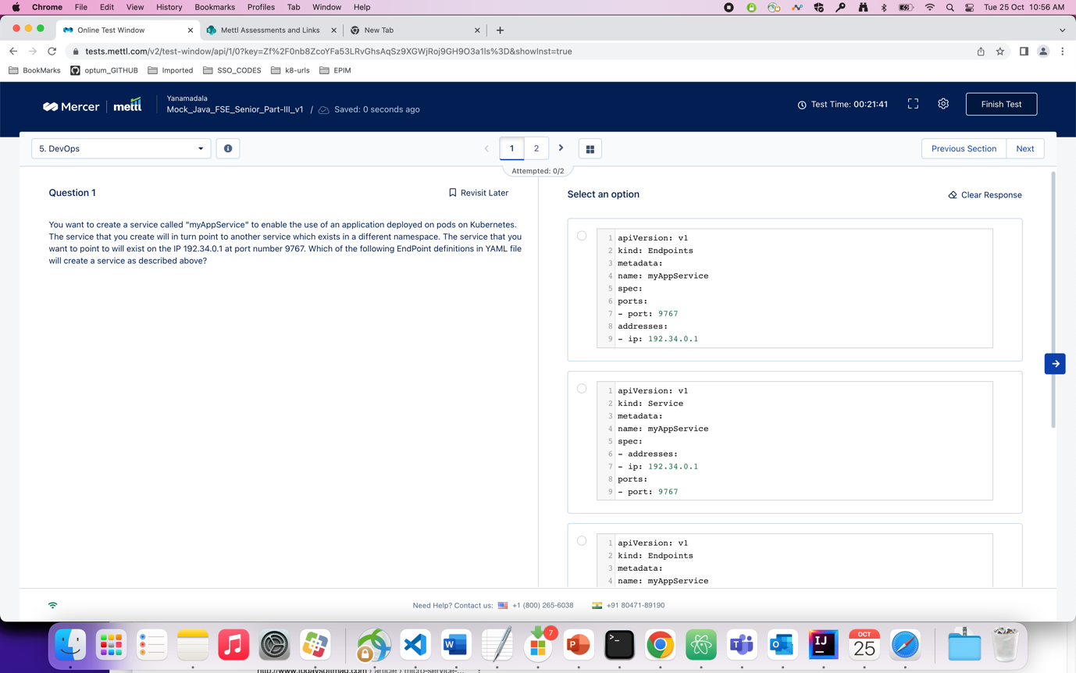

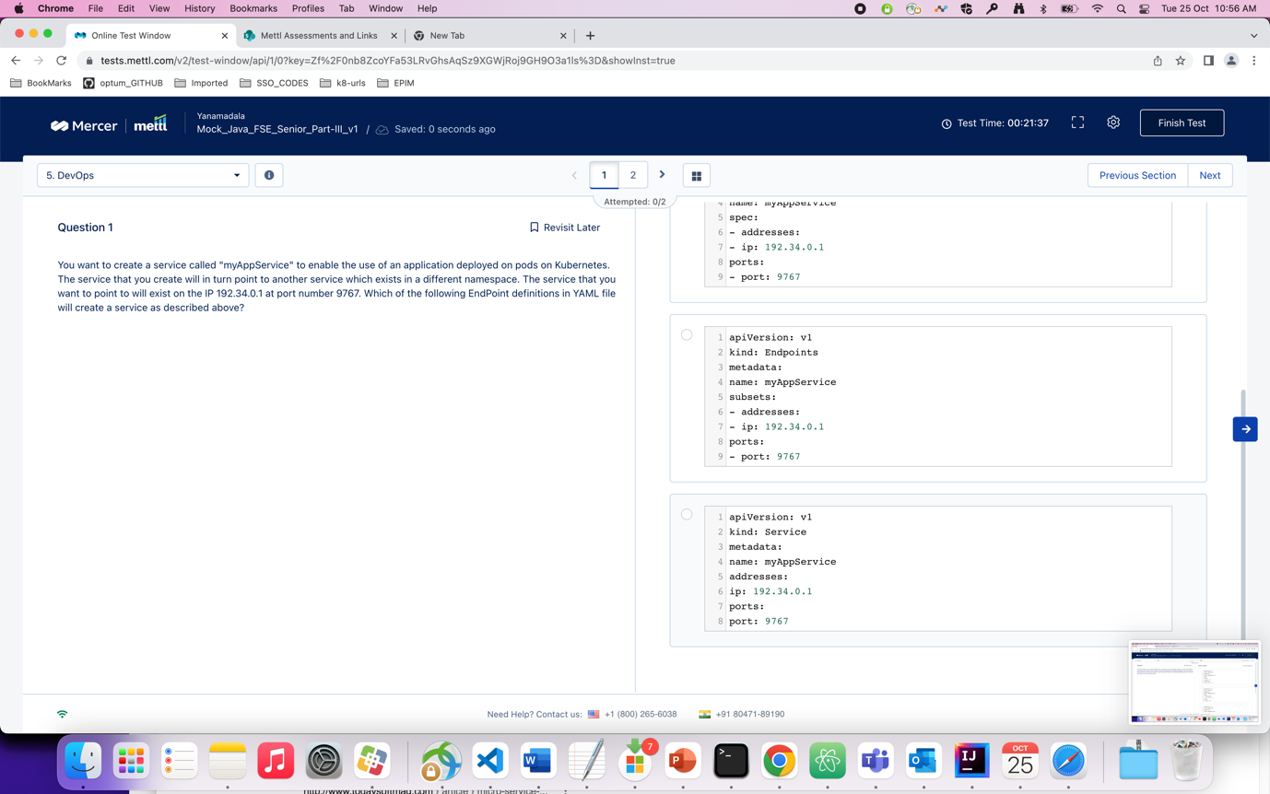

Question : by default which mode do docker containers run in and what is the value of -d option…

Ans : 1

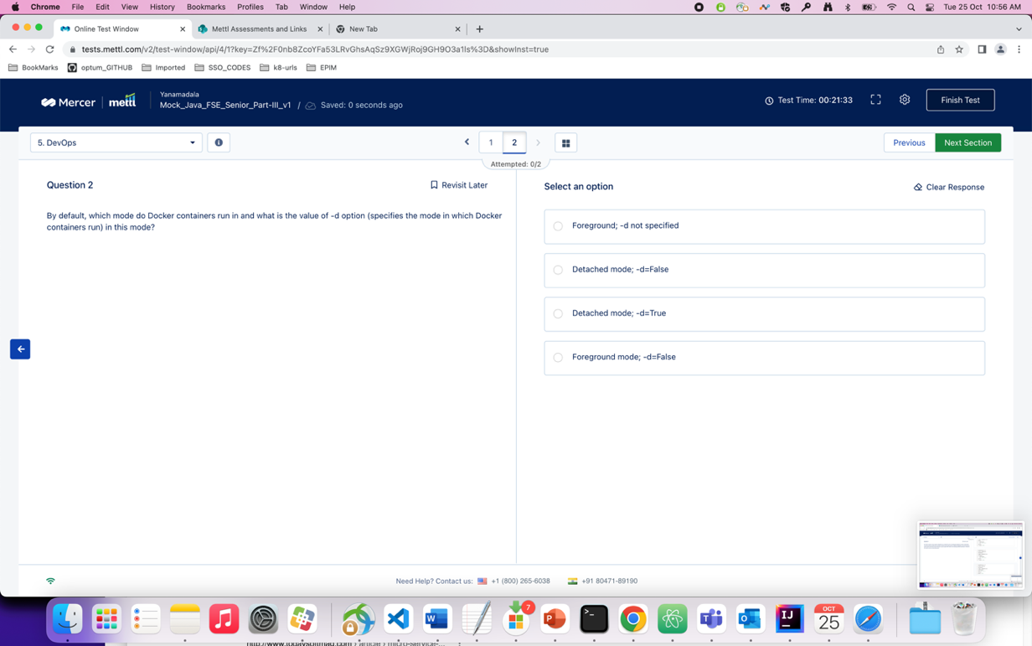

Question : which of the following is correct with respect to the design thinking process

Ans : 1

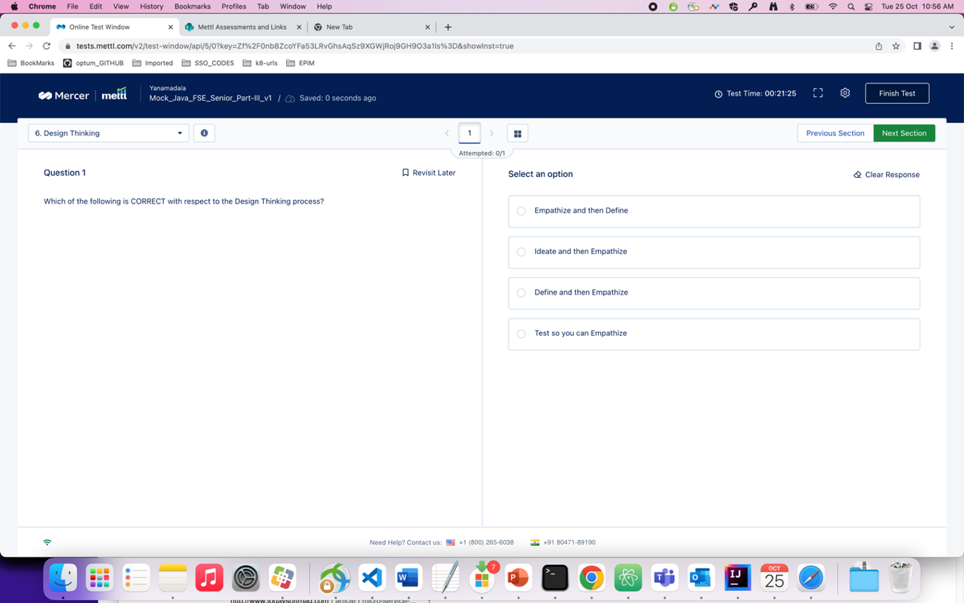

Question : which of the following is the correct option of mapping related to the given schema ?

Ans : 2. (approx.)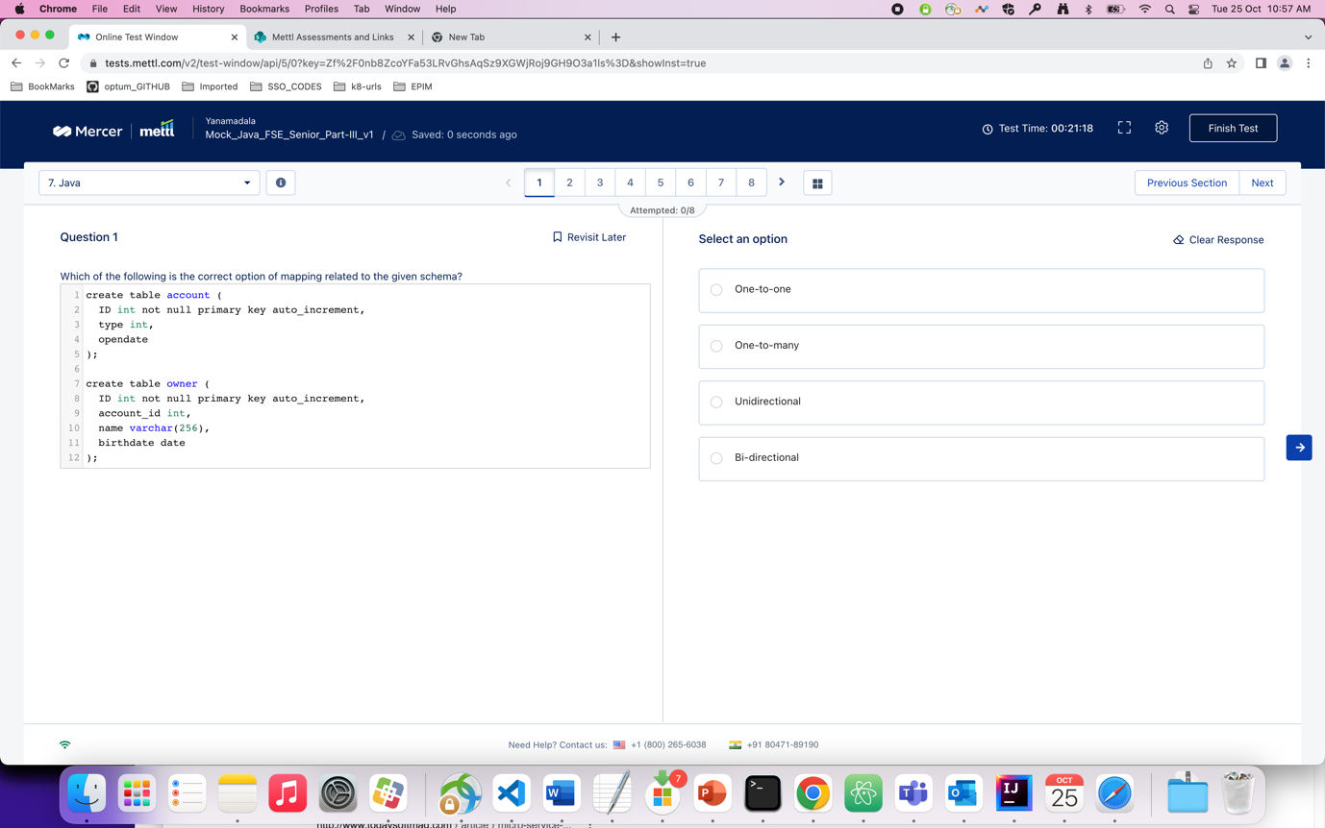

Question : what will be the output of the following code snippet ?

Ans : 1

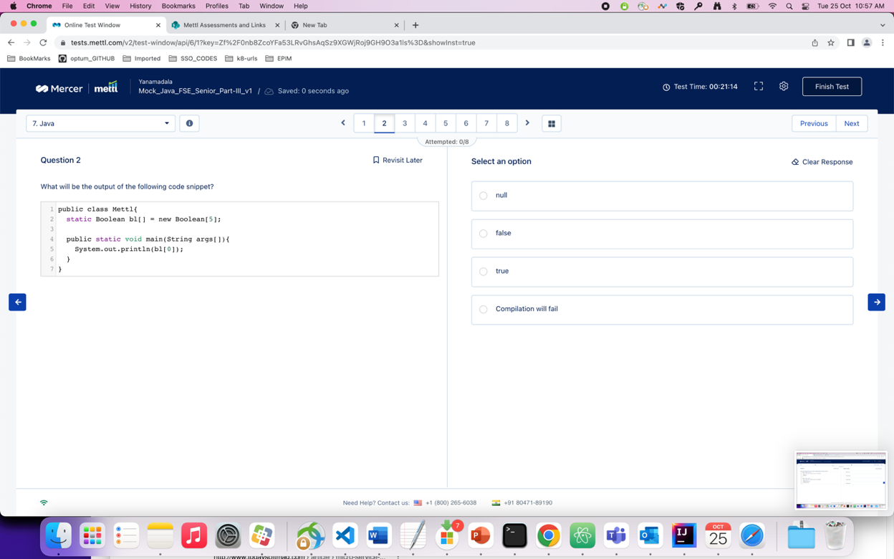

Question : considering the following code snippet, the variable ‘df’ is an object of DateFormat that has been initialized……

Ans : 3. ( Local is there instead of Locale )

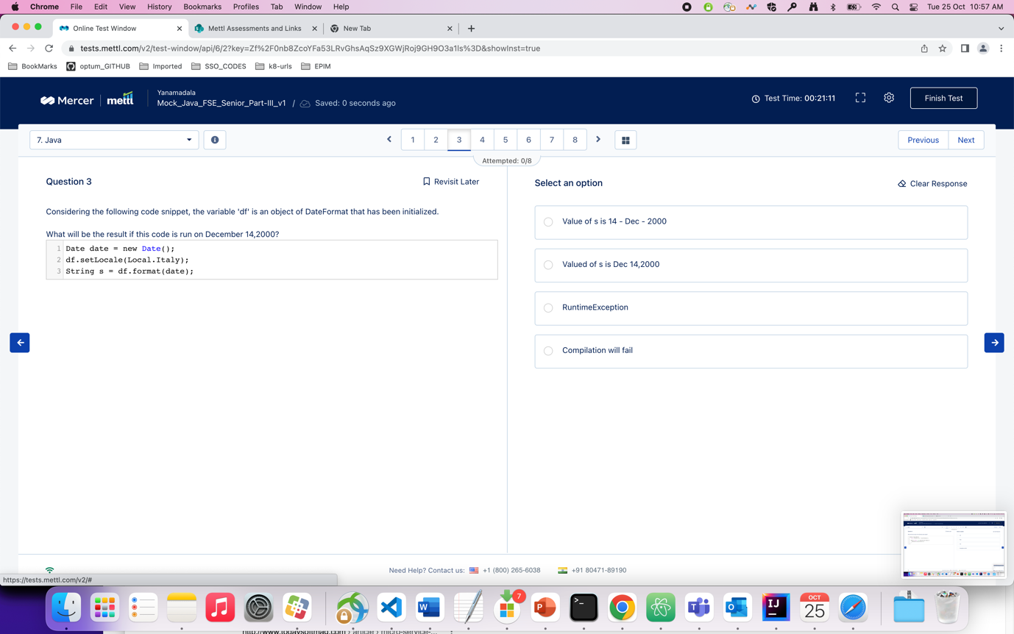

Question : what will be the output of the following code snippet ?

Ans : 1

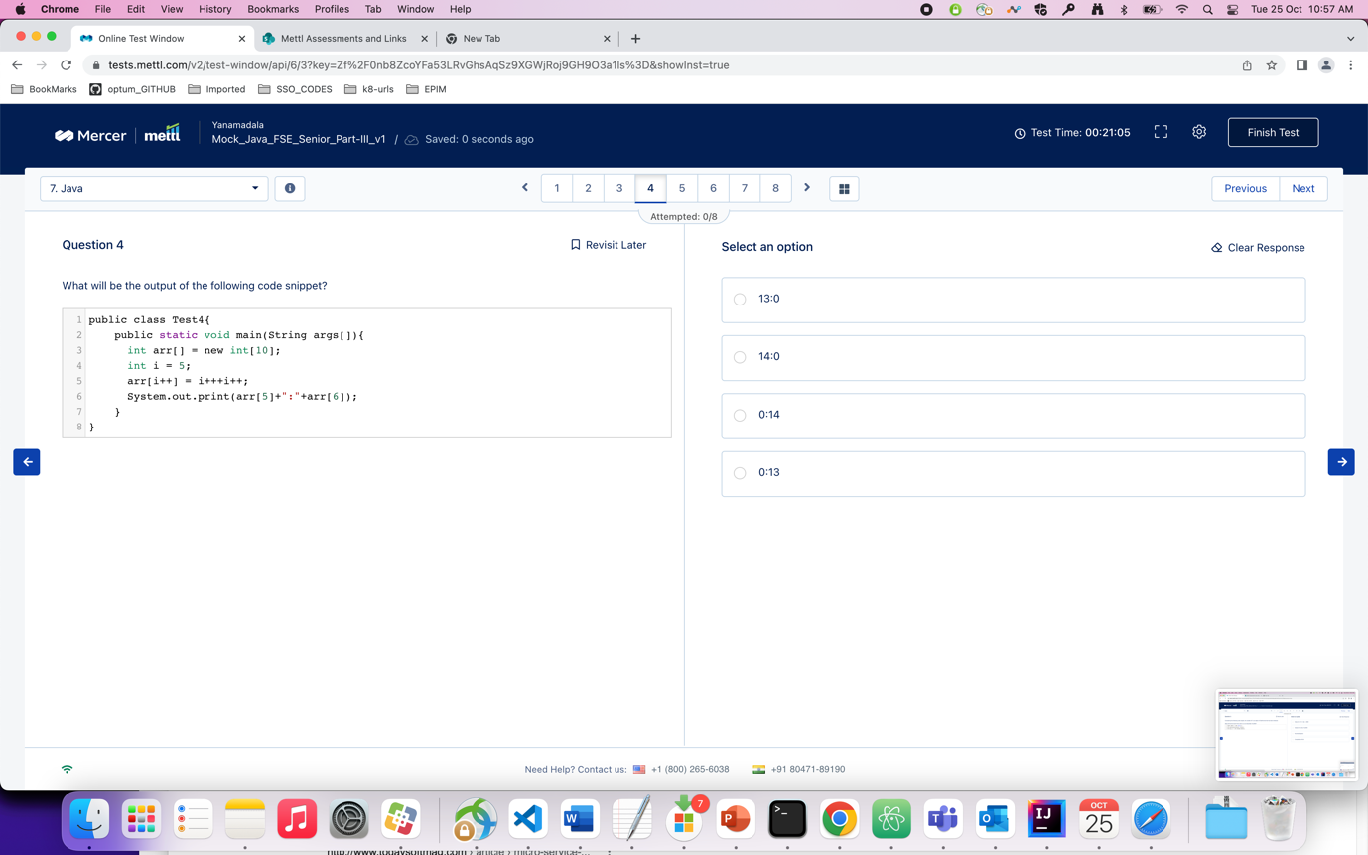

Question : what will be the output of the following code snippet ?

Ans : 3

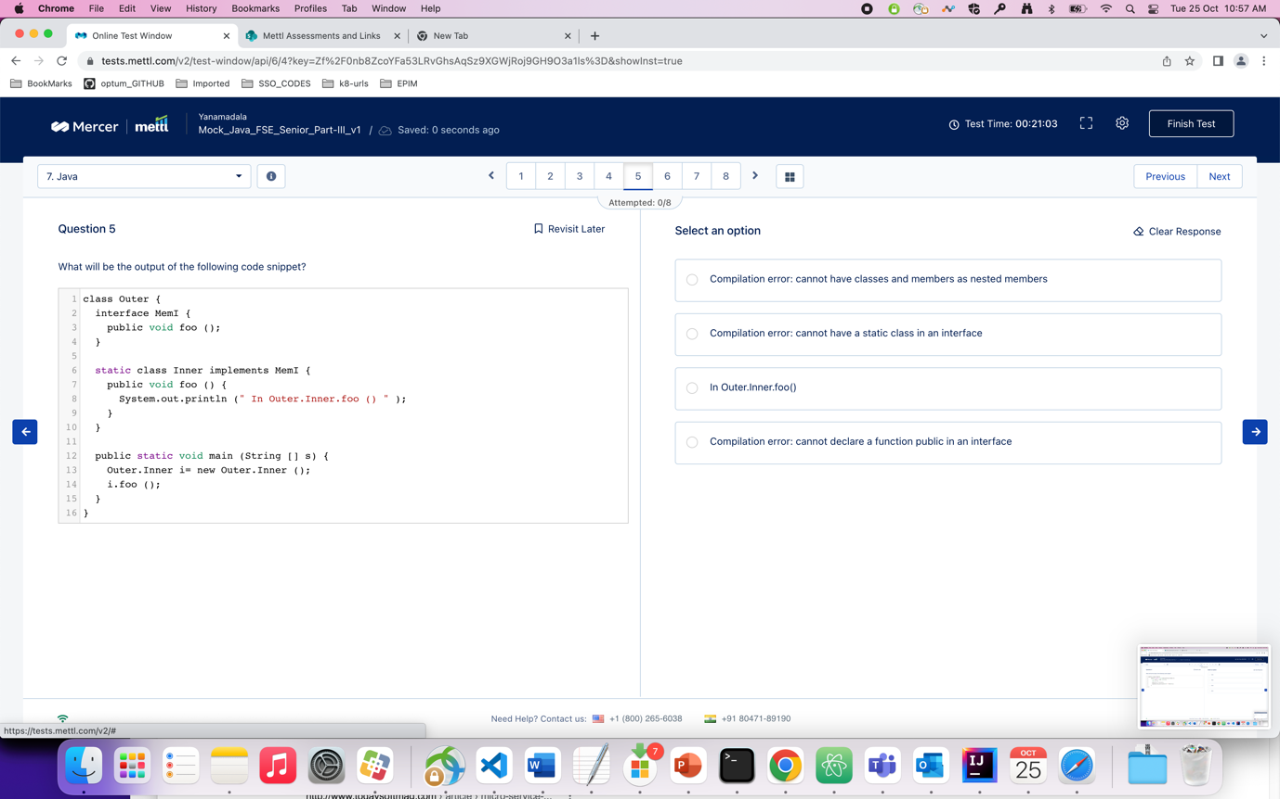

Question : what will be the output of the following code snippet ?

Ans : 2

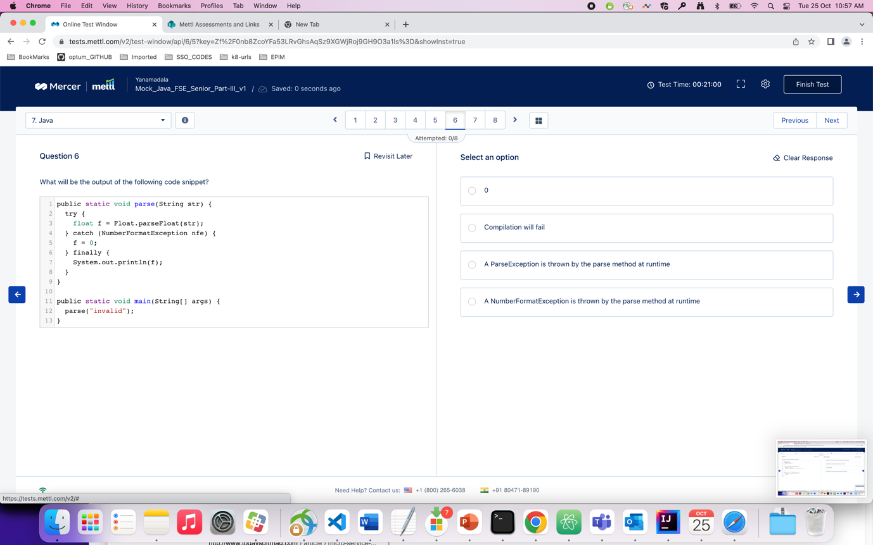

Question : what will be the output of the following code snippet ?

Ans : 4

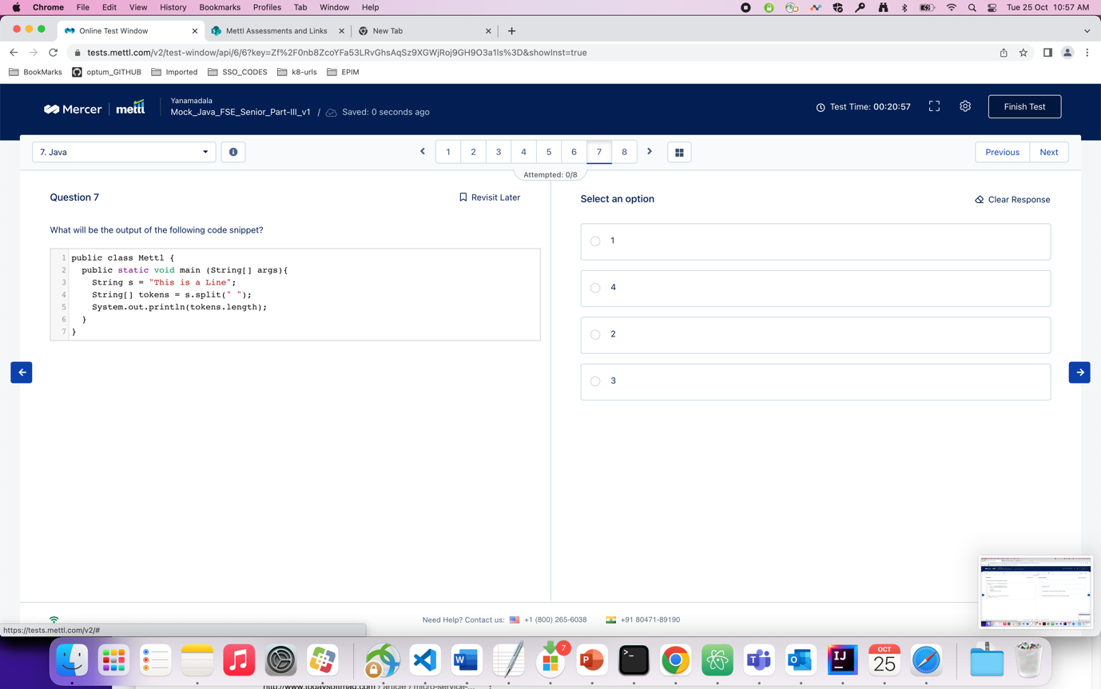

Question : which of the following annotations supports the automatic conversion of exceptions from one type to another in java spring ?

Ans : 4. ( Repository )

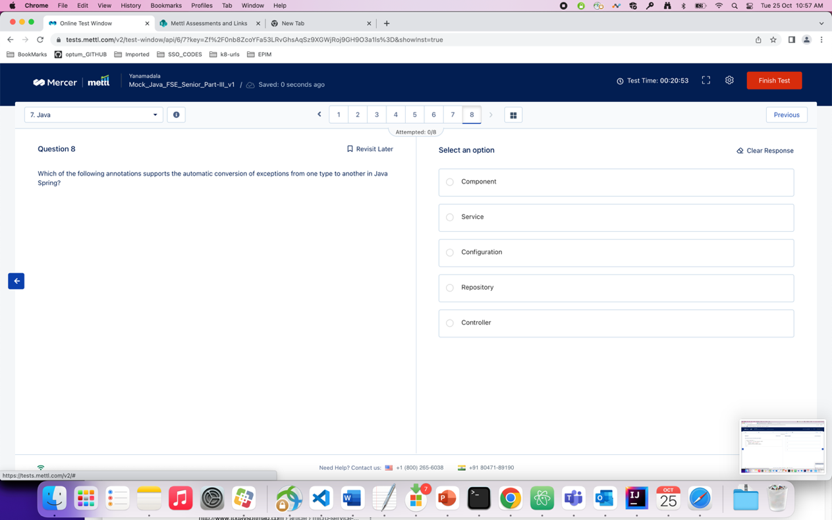

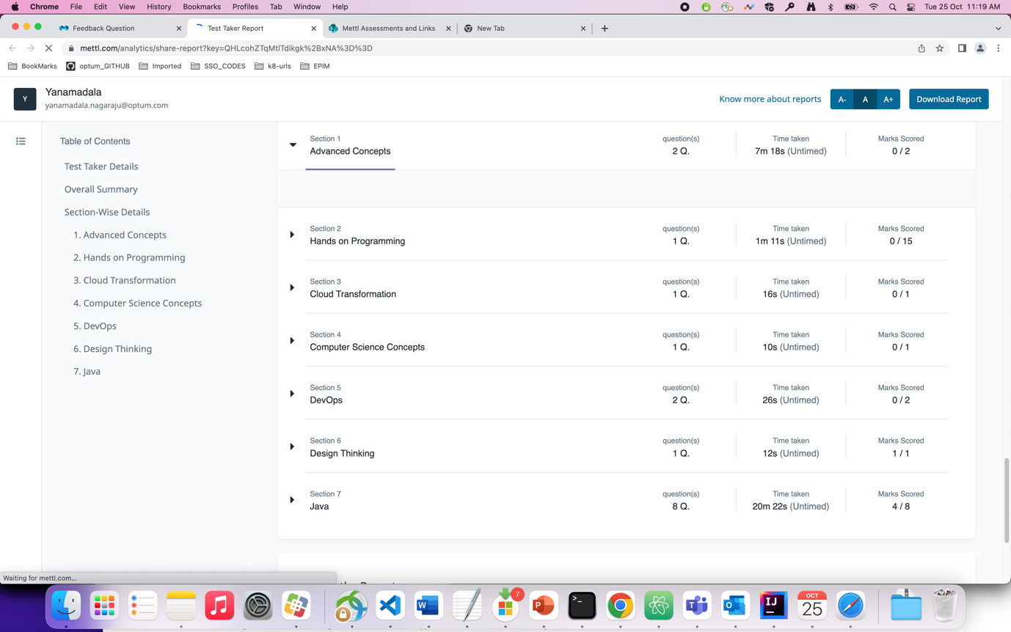

# Mock Test -2 (part-3)

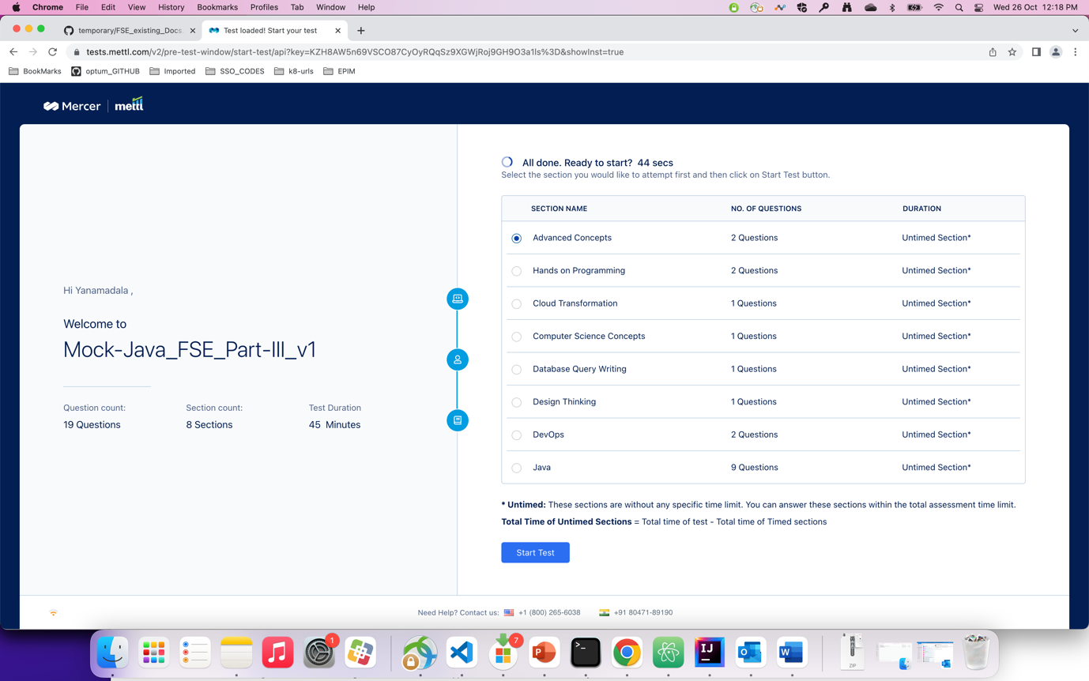

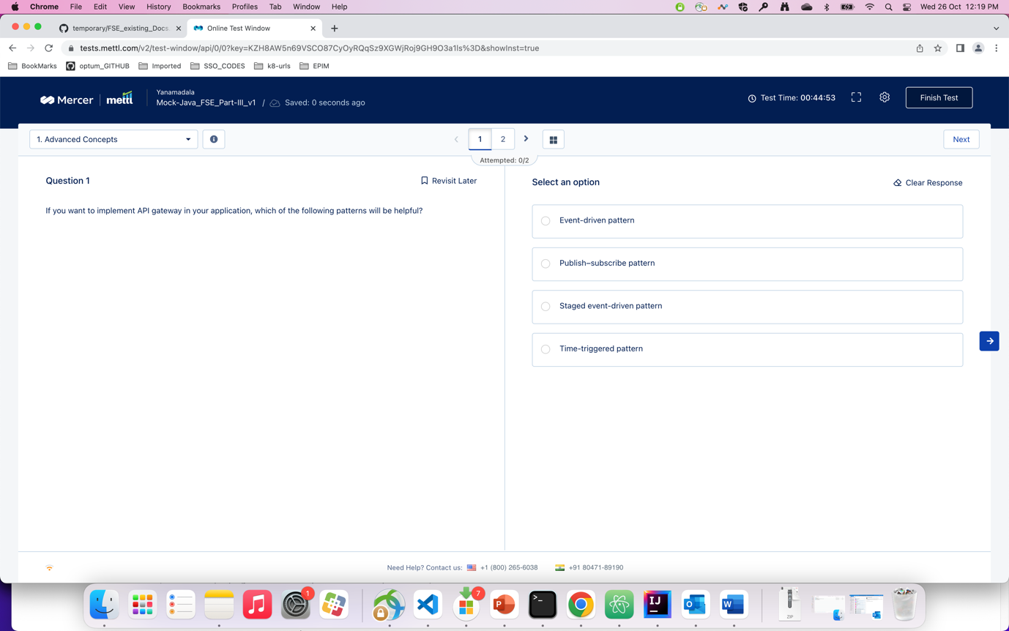

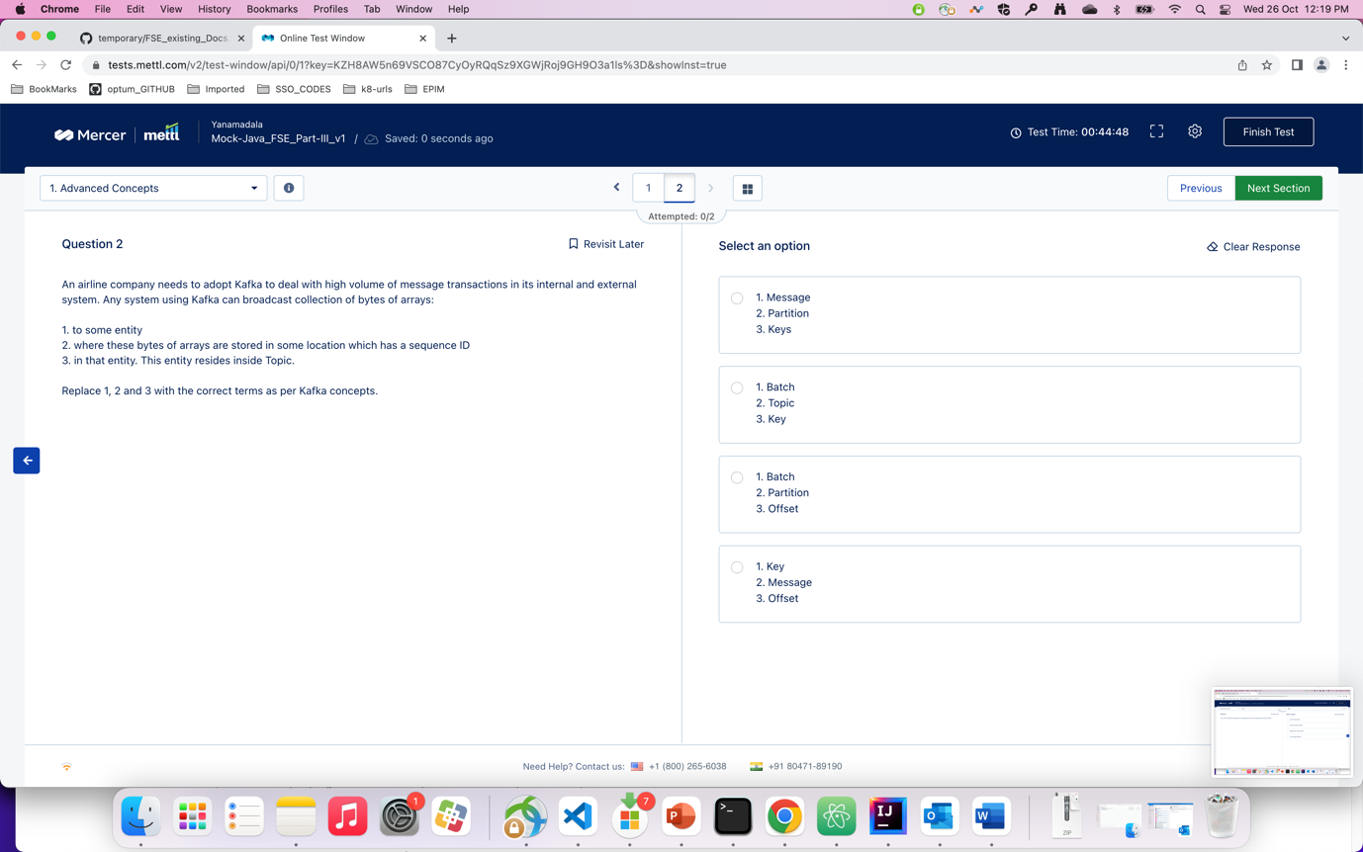

Question : html program to find list scroll left and right

Ans :

<https://codereview.stackexchange.com/questions/132397/prev-next-buttons-for-a-circular-list>

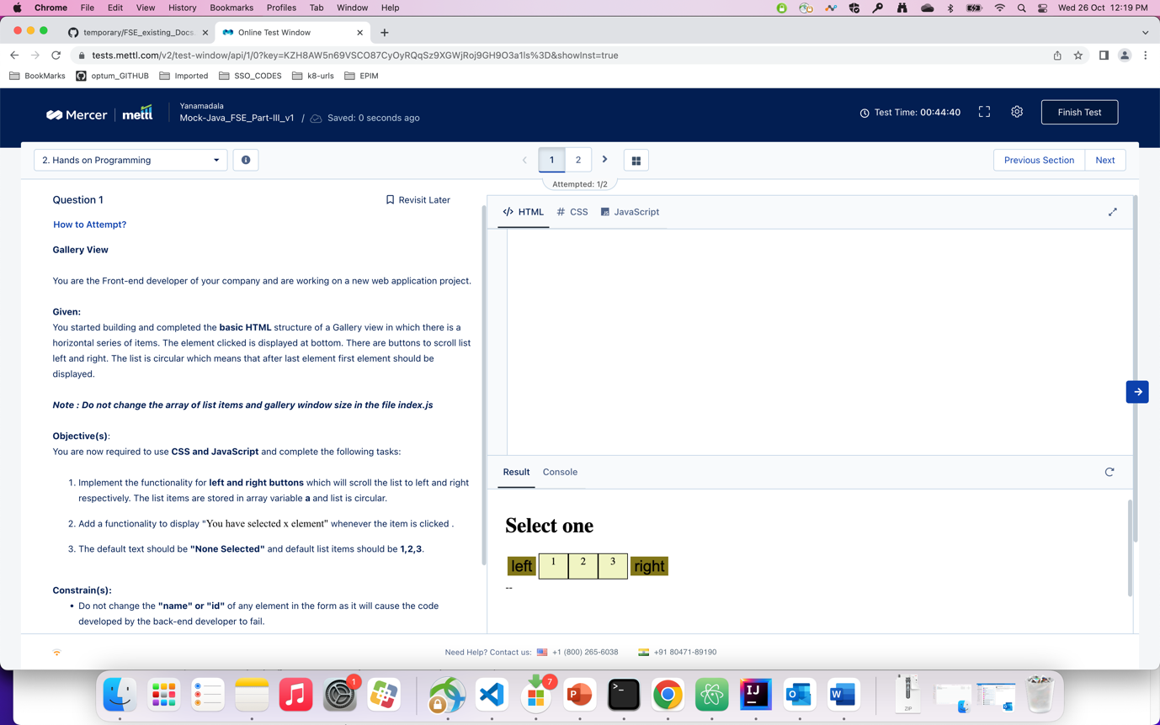

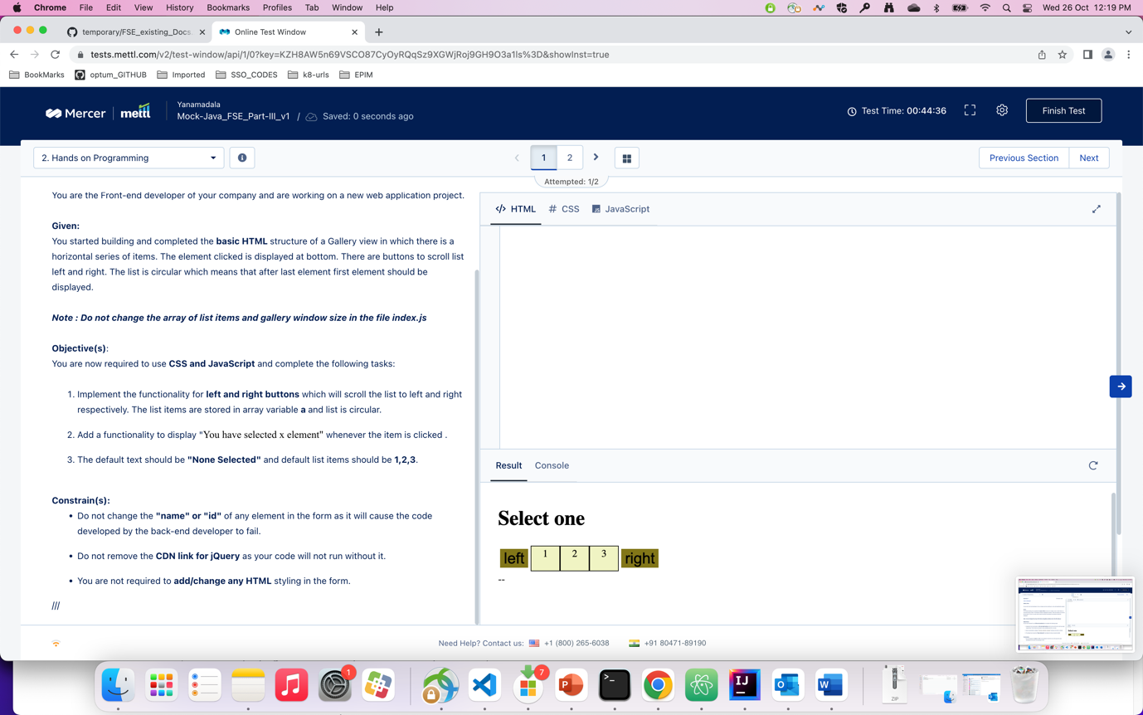

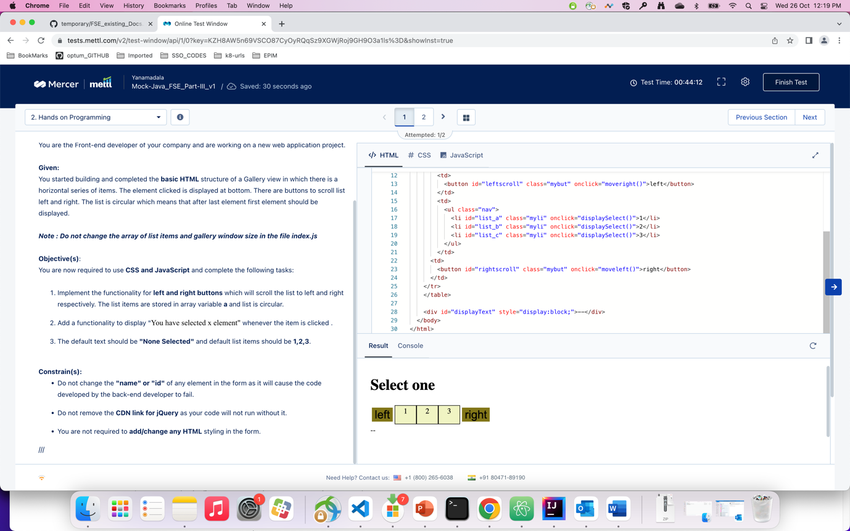

Ans : below program

<!DOCTYPE html>

<html>

<head>

<style>

.outer {

overflow-x: hidden;

overflow-y: hidden;

}

.container {

display: flex;

transition: transform .4s ease-in;

}

.inner {

flex: 0 0 25%;

height: 100px;

margin:10px;

}

.paddle {

position: absolute;

top: 50px;

bottom: 0;

width: 30px;

height:20px;

}

.lefty {

left: 0;

z-index:1;

}

.righty{

right: 0;

z-index:1;

}

</style>

</head>

<body>

<div id="displayy" class = "defalutt">defaultText</div>

<button class="lefty paddle" id="left-button"></button>

<div class="outer" id="content">

<div class="container">

<div id="list_a" class="inner" style="background:red" onclick="displaySelect(event)">1</div>

<div id="list_b"class="inner" style="background:green" onclick="displaySelect(event)">2</div>

<div id="list_c"class="inner" style="background:blue" onclick="displaySelect(event)">3</div>

</div>

</div>

<button class="righty paddle" id="right-button"></button>

<script>

const container = document.querySelector(".container");

const lefty = document.querySelector(".lefty");

let translate = 0;

let a = [];

let defaultText= "None selected";

let selectedText = "";

function displaySelect(event){

//alert("selected "+event);

a = [];

a[1] = event.target.innerHTML;

selectedText = "You have selected " + a[1]+ " element";

document.querySelector(".defalutt").innerHTML = selectedText;

}

lefty.addEventListener("click", function() {

if((translate >= 600)|| (translate <= -600)){

translate = 0;

}else{

translate -= 200;

}

container.style.transform = "translateX(" + translate + "px" + ")";

if(a.length == 0){

document.querySelector(".defalutt").innerHTML = defaultText;

}else{

}

});

const righty = document.querySelector(".righty");

righty.addEventListener("click", function() {

if((translate >= 600)|| (translate <= -600)){

translate = 0;

}else{

translate += 200;

}

container.style.transform = "translateX(" + translate + "px" + ")";

document.querySelector(".defalutt").innerHTML = defaultText;

});

</script>

</body>

</html>

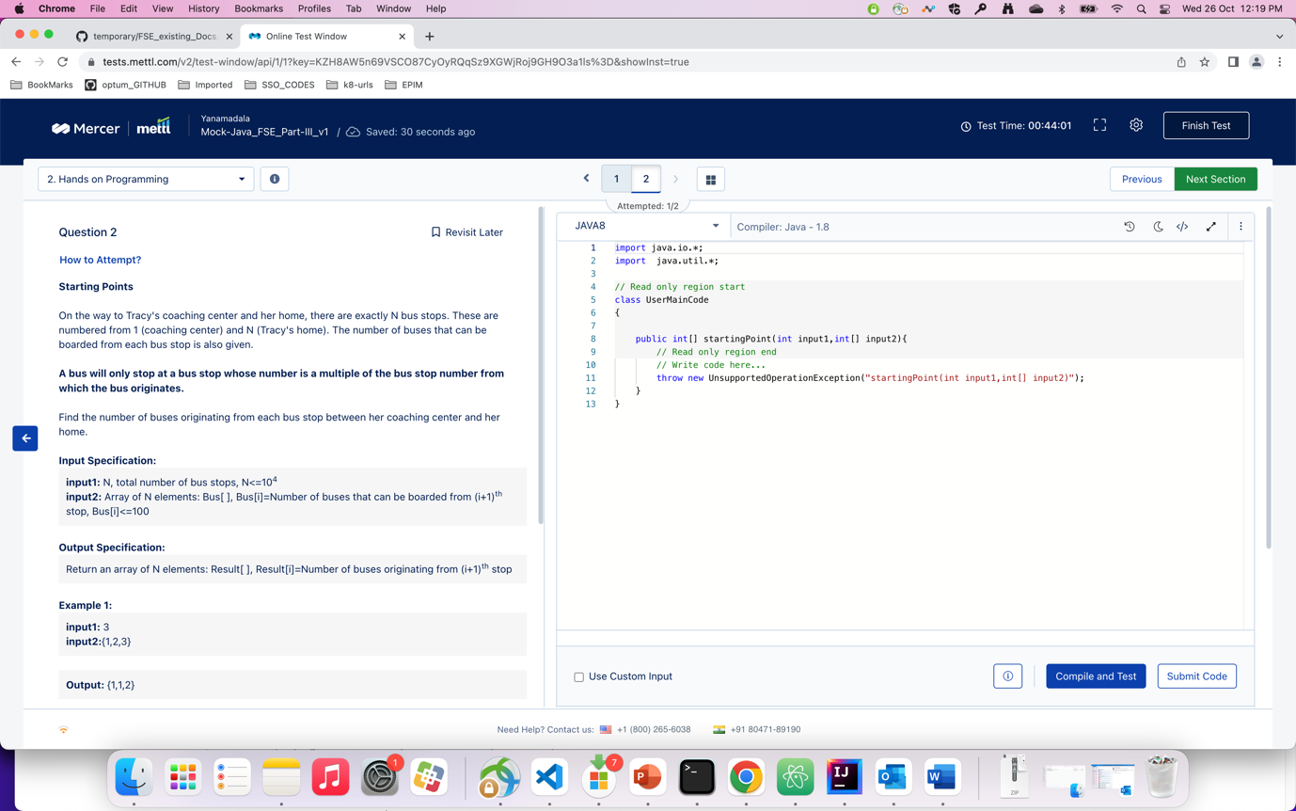

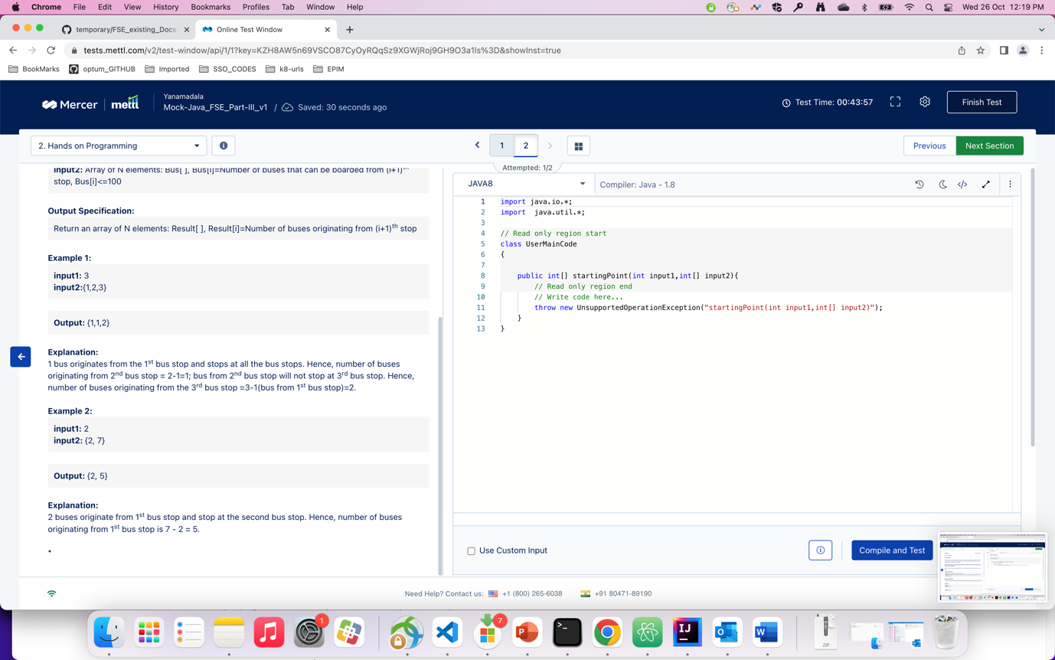

Ans : program

package com.optum.mdm.pmdmui.config;  
  
import java.util.Scanner;  
  
class Result  
{  
 int[] output1 = new int[10005];  
}  
  
public class Test {  
  
 public static void main(String[] args) {  
 // System.out.println(b1[0]);  
 Scanner s = new Scanner(System.*in*);  
 int n = s.nextInt();  
 int[] arr = new int[n];  
 for(int i=0;i<n;++i){  
 Scanner s1 = new Scanner(System.*in*);  
 arr[i] = s.nextInt();  
 }  
 Result ans;  
 ans = *startingPoint*(n,arr);  
 for(int j=0;j<n;j++){  
 System.*out*.println(ans.output1[j]);  
 }  
 }  
  
 static Result startingPoint(int input1, int input2[]){  
  
 int n = input1;  
 Result ans = new Result();  
 for(int j=1;j<=n;j++){  
 ans.output1[j-1] = input2[j-1];  
 for(int i=1;i<j;i++){  
 if(j%i == 0){  
 ans.output1[j-1] -= ans.output1[i-1];  
 }  
 }  
 }  
 return ans;  
 }  
  
}



Question : which of the following components in ACS claims transformation rules that you specify for your RP. ?

Ans : 4. Rule engine

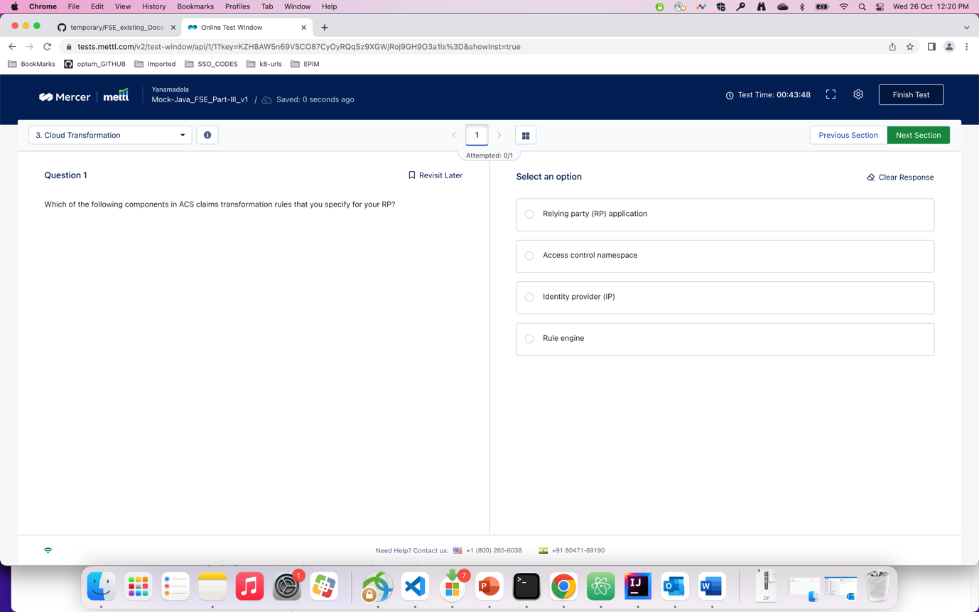

Question : which of the following options is not a limitation of binary search algorithm

Ans : 4

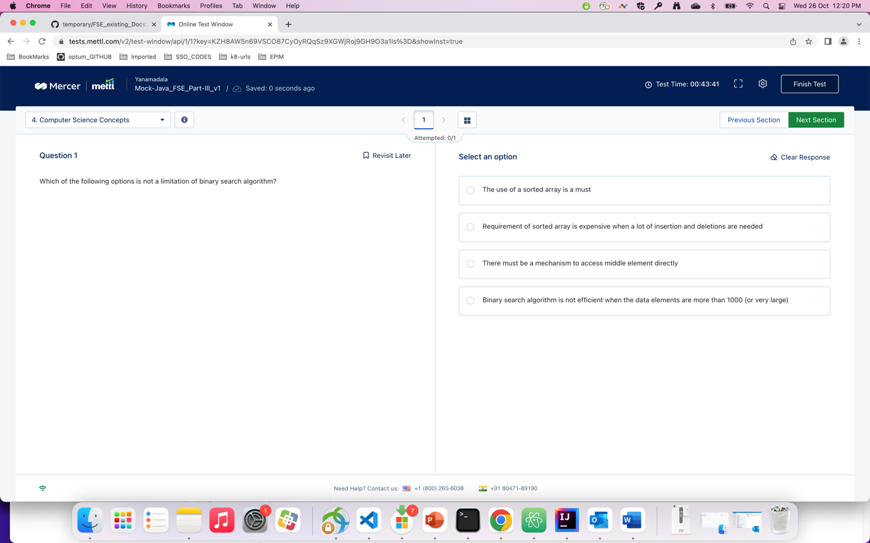

Q ) query the department id and average allotted leaves for each department. The result must be grouped according to the department ID…

Ans ). ?

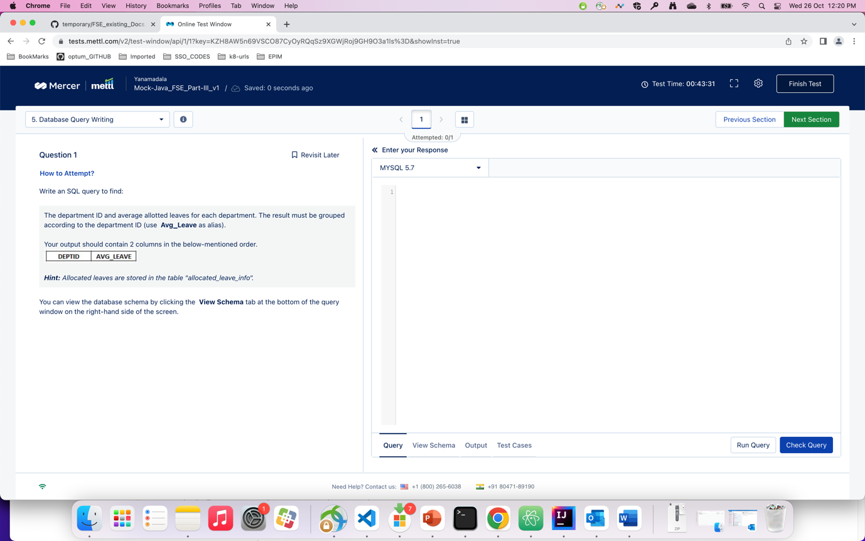

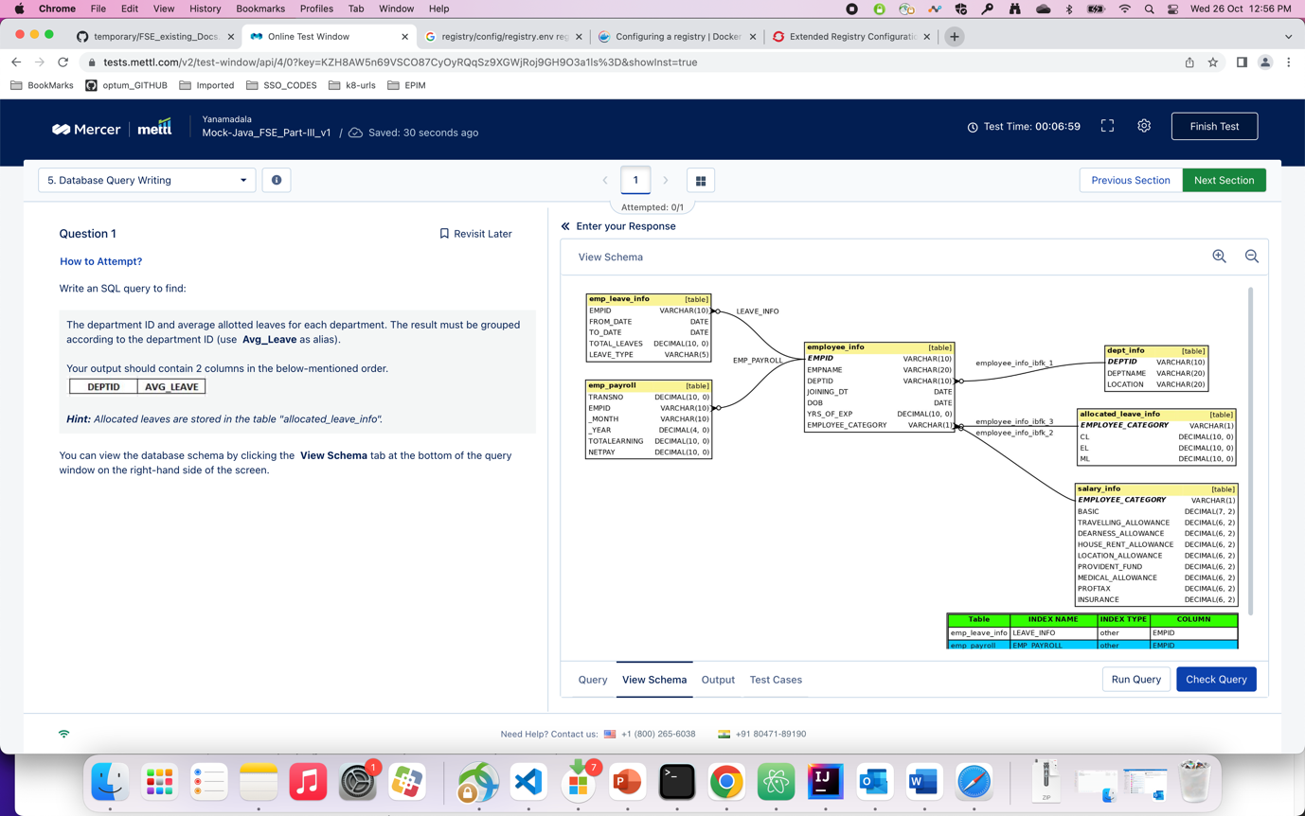

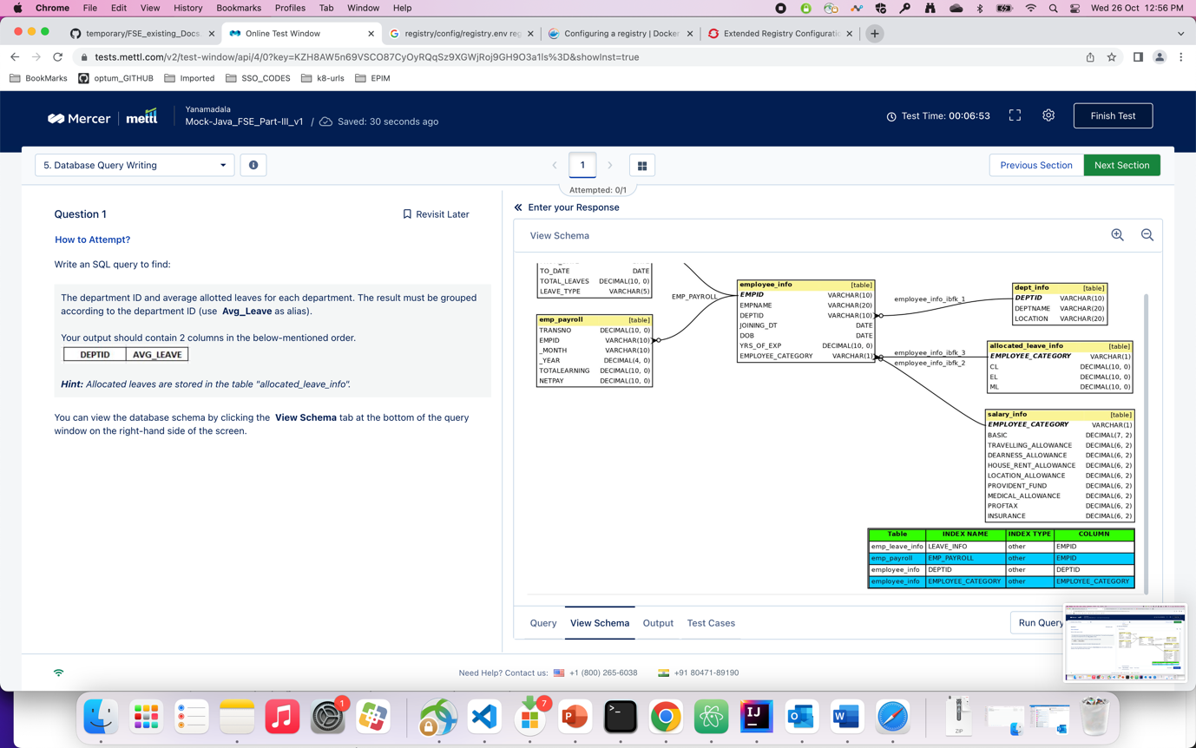

Q ) after an exceptional design thinking brainstorming session, a team decided to implement…

A). 2. ( they should have built prototypes for the ideas…)

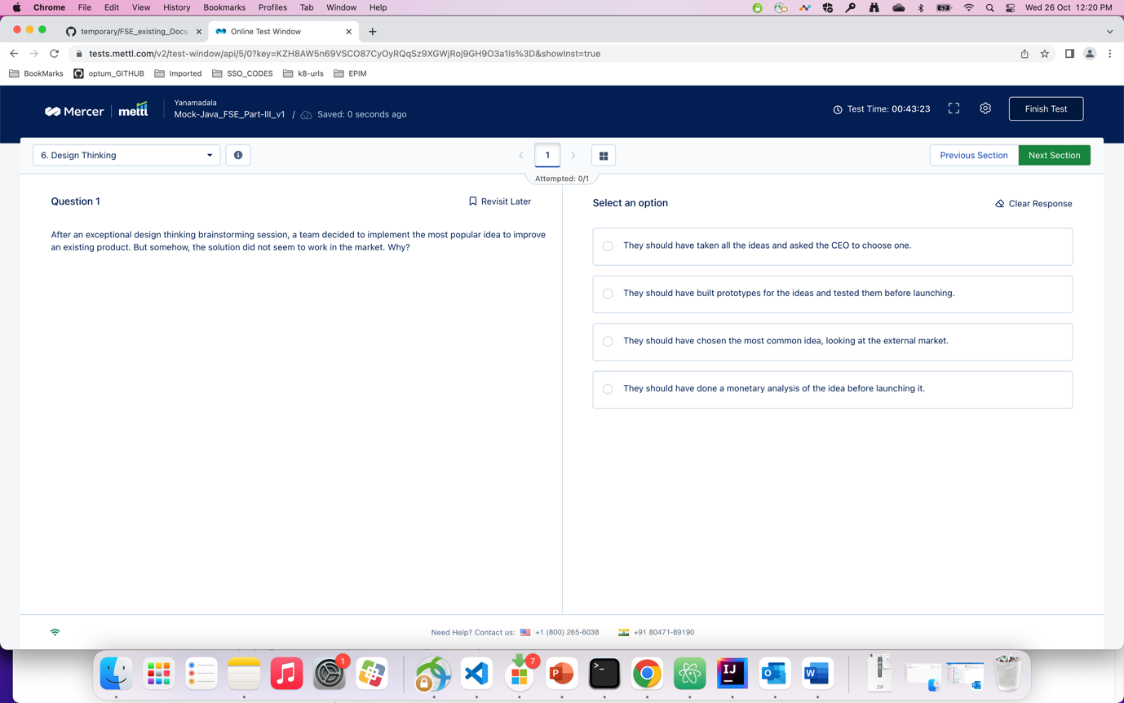

Q) for a high scale production environment, is Minikube enough for deployment ?

A). 3

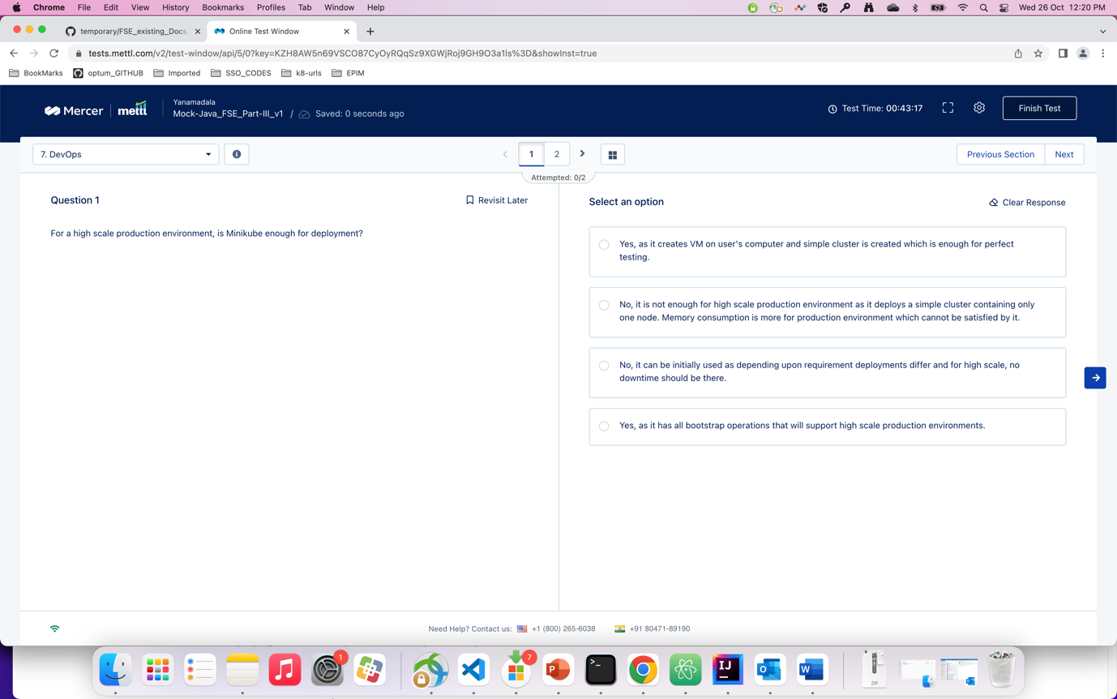

Q) which command do you use when you are working on the register of the container ?

A) 3 (/etc/register….)

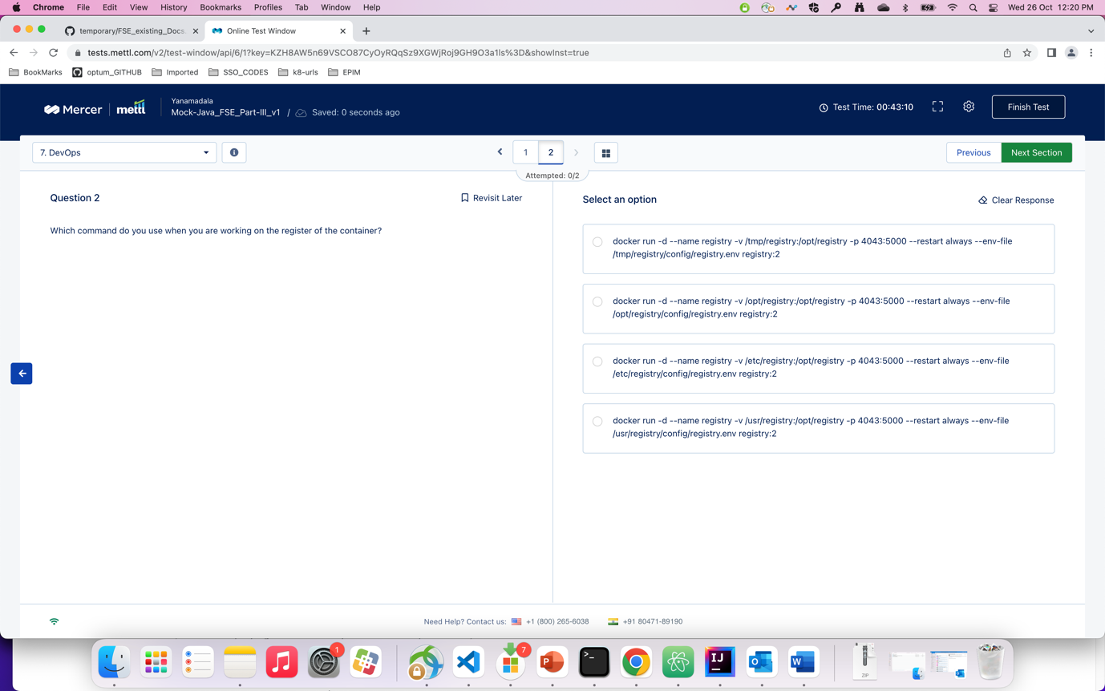

Q) which of the following is the correct option of mapping related to the given schema ?

A) 3. Mostly. (. May be 1. As well )

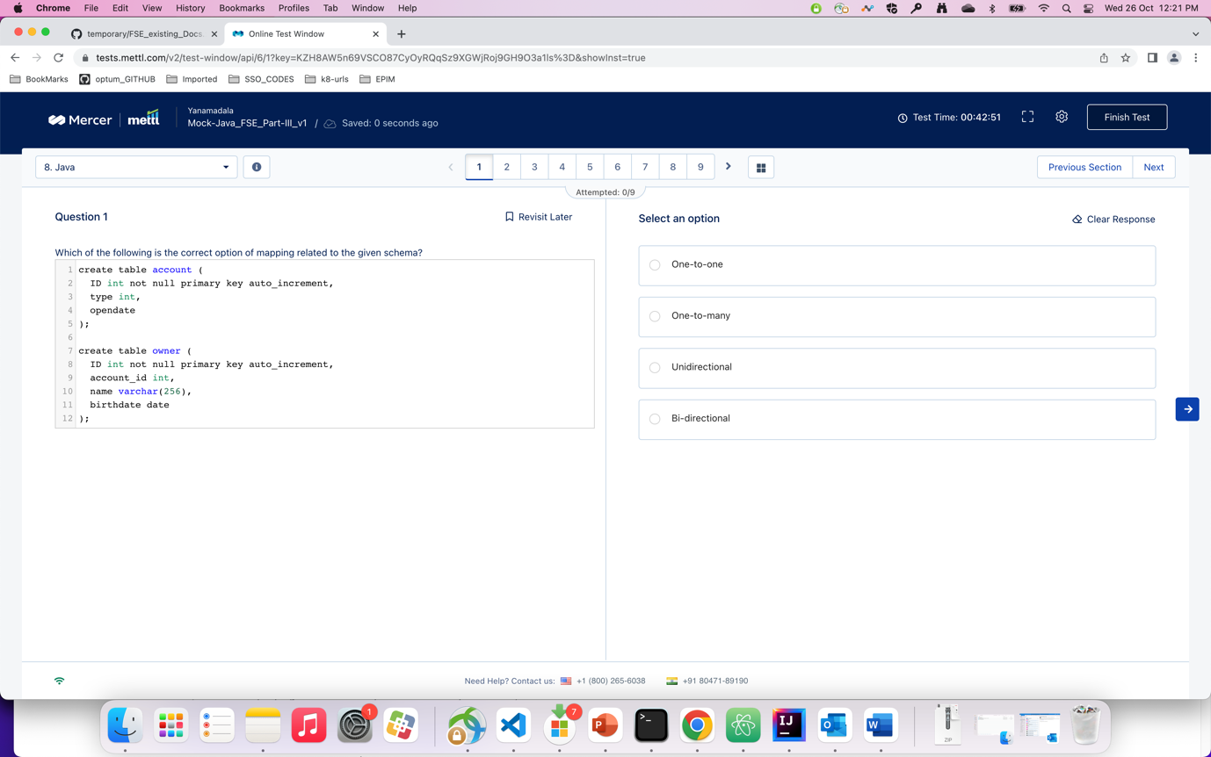

Q) There is a SQL table which contains records of students, where studentID is the primary key…..

A) 1

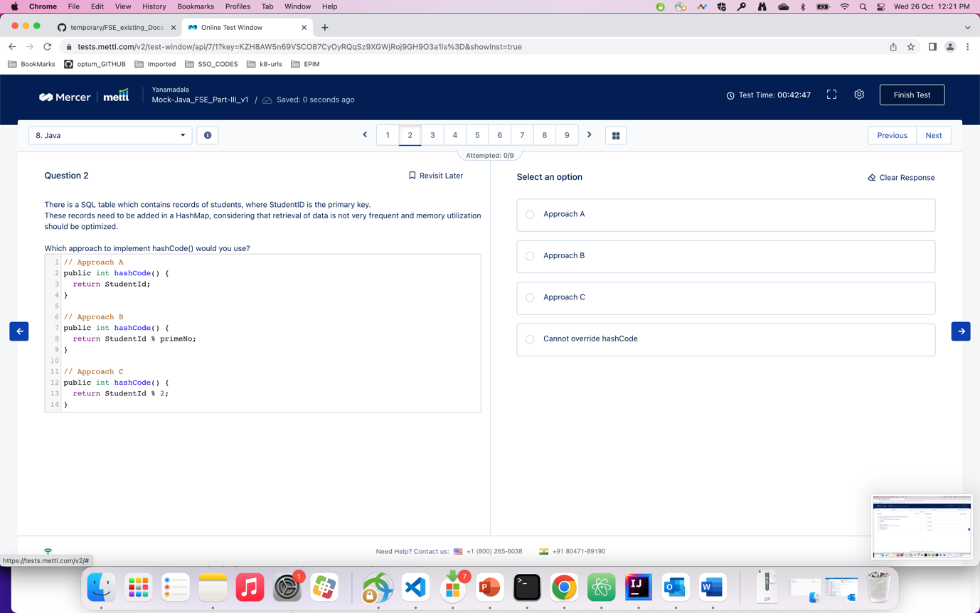

Q) which of the given options is the correct code that prints the largest element in the given arry

A) 3

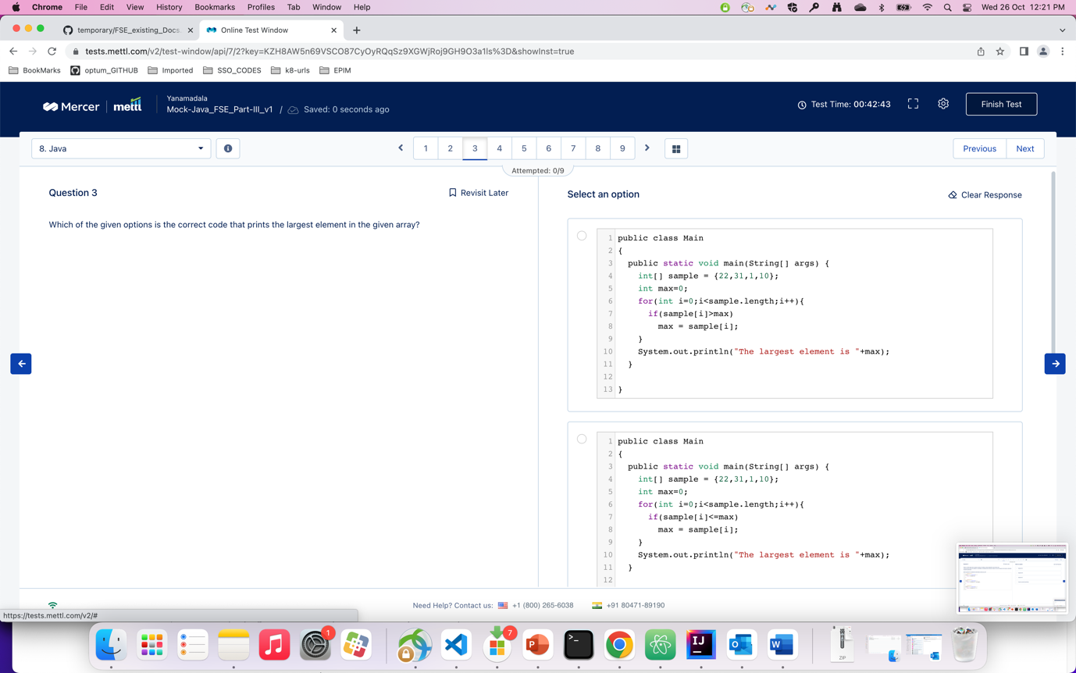

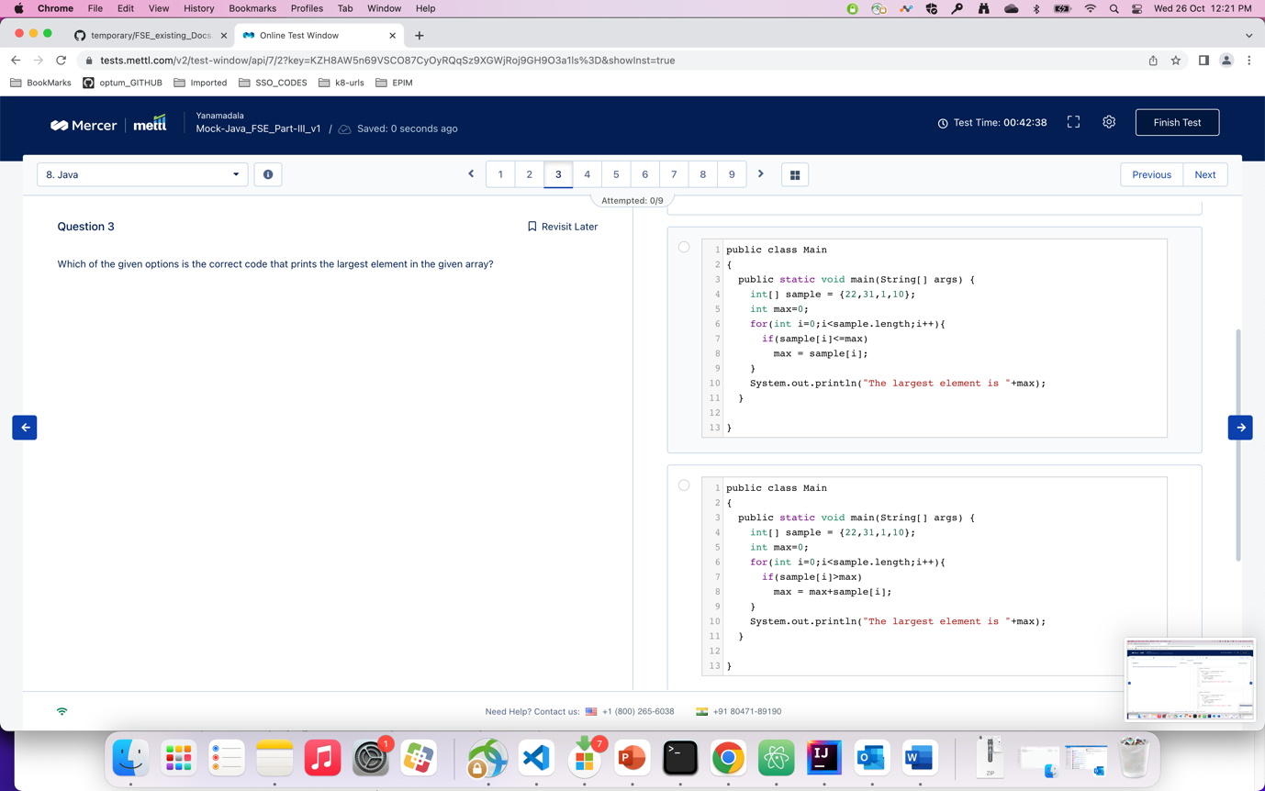

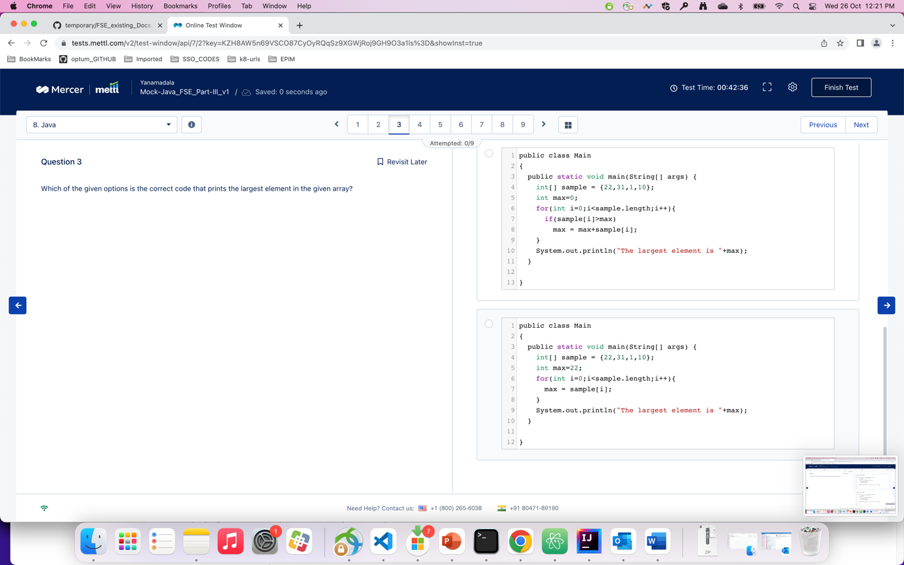

Q) what will be output of the given code ?

A) 2

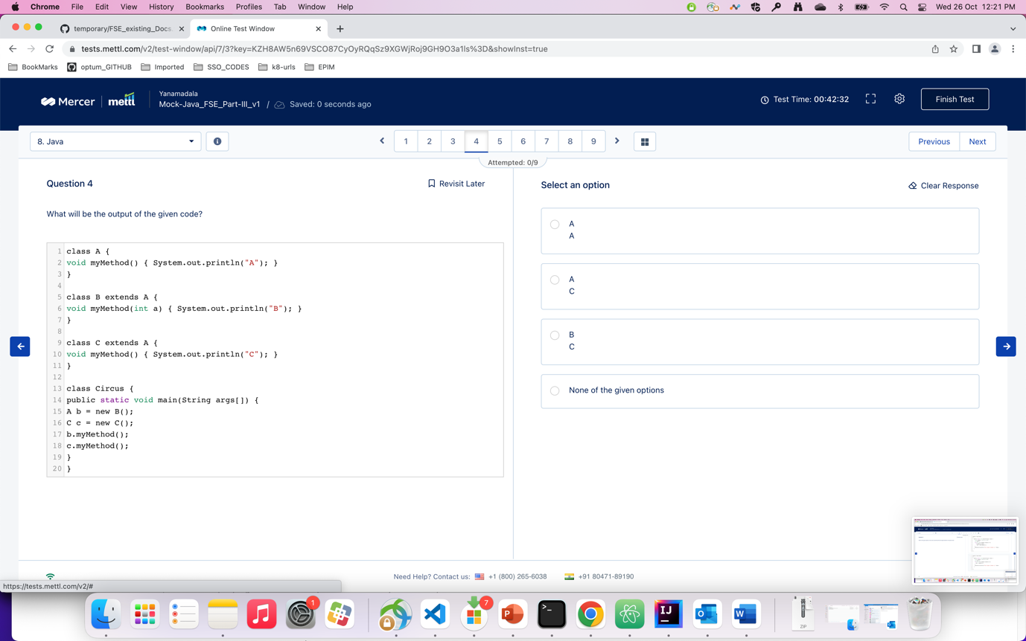

Q) Packages stored in JAR files can be optionally ssealed to which of the following options ?

A) 2

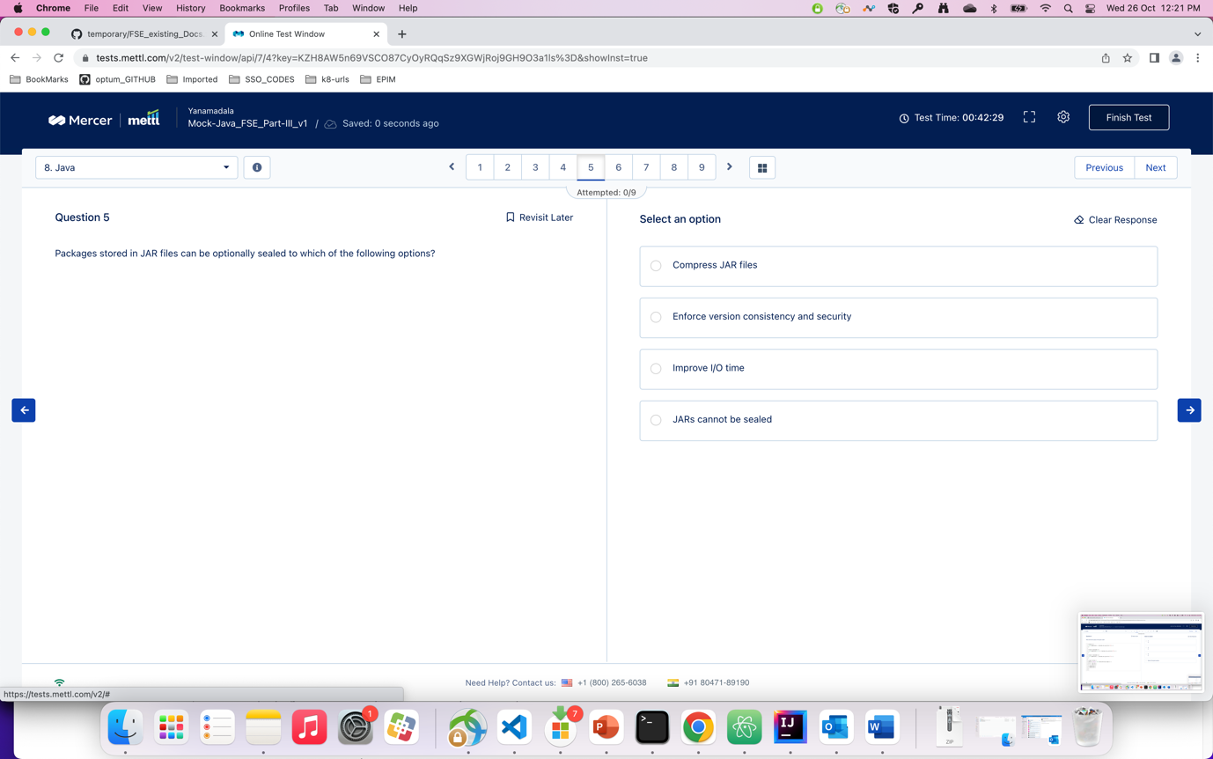

q) what would be the output of the following code ?

A). answer is not there ( actual ans : java, unix )

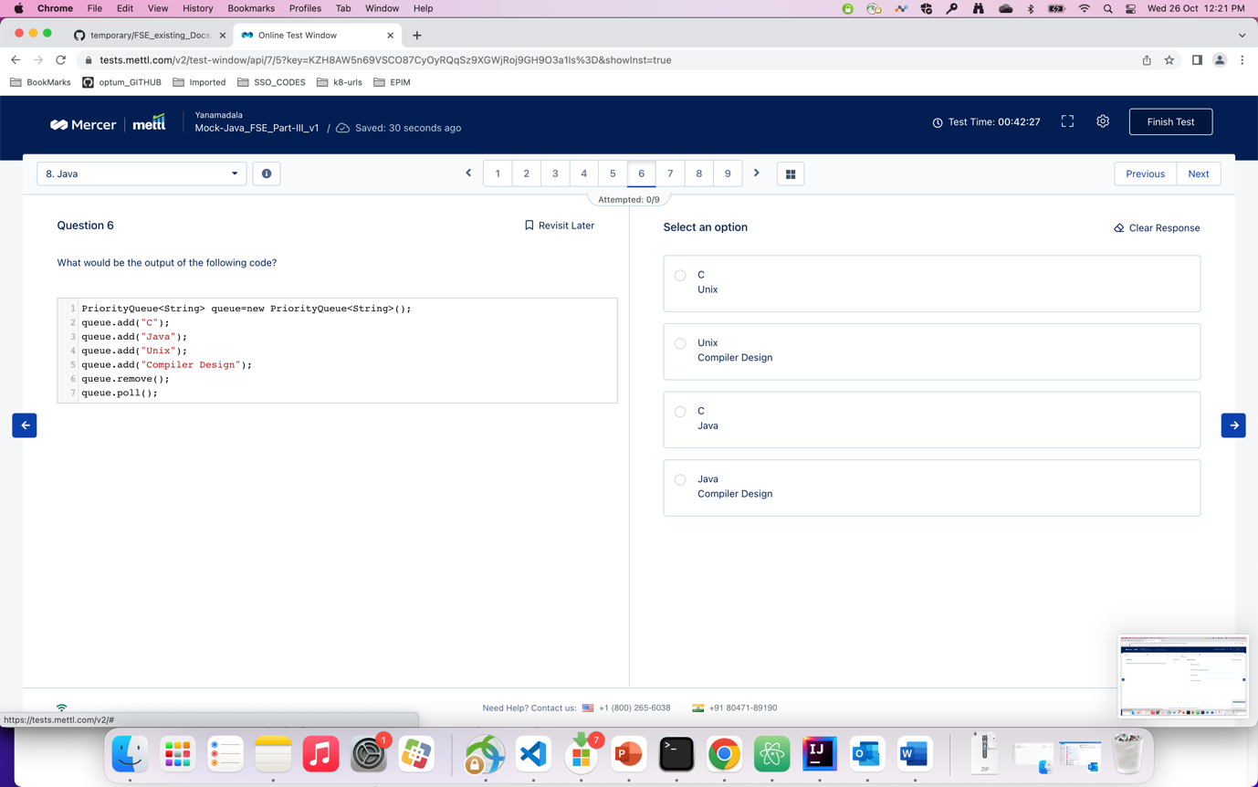

Q) what would be the output of the following code ?

A) 1

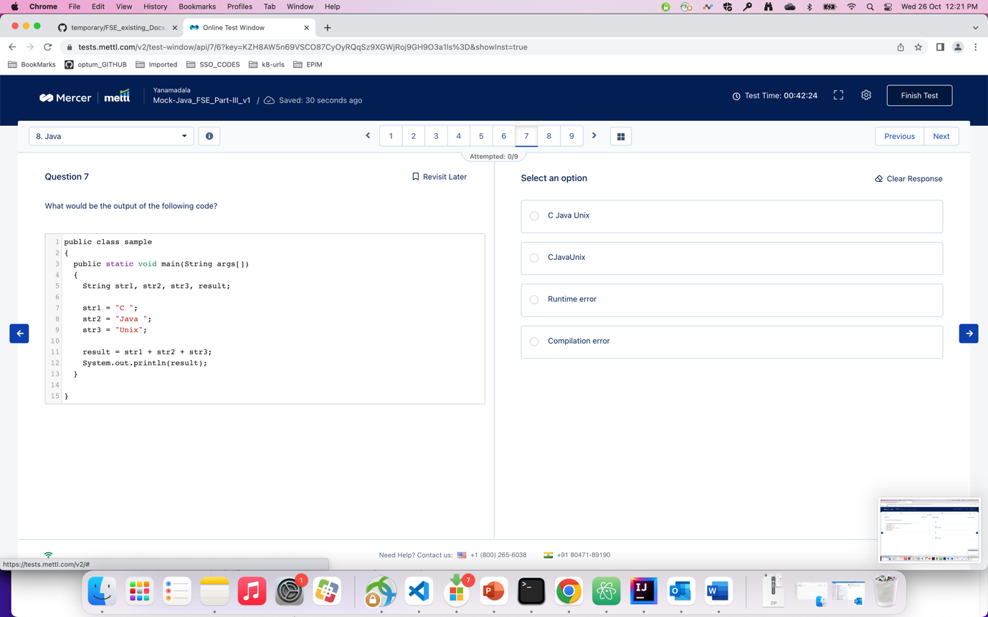

Q) Considering the following code snippet, which of the given methods will return the most accurate result if you are ….

A) 2

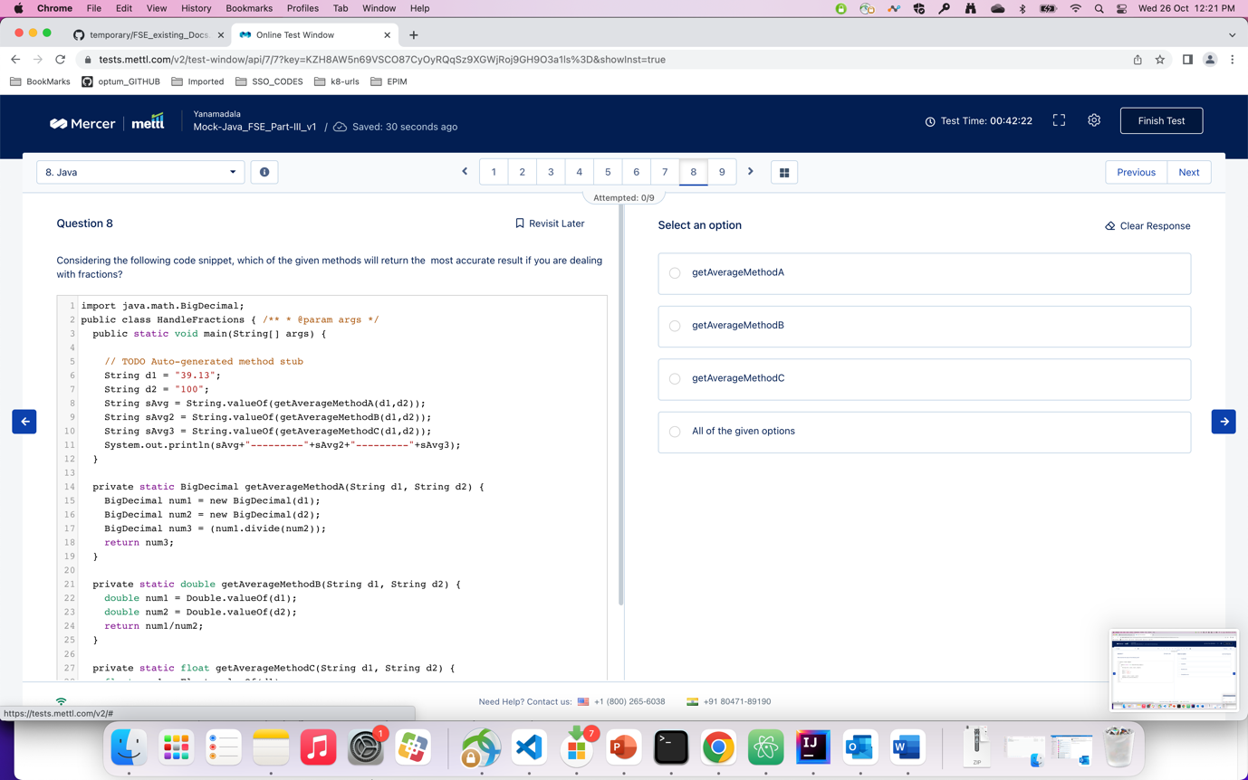

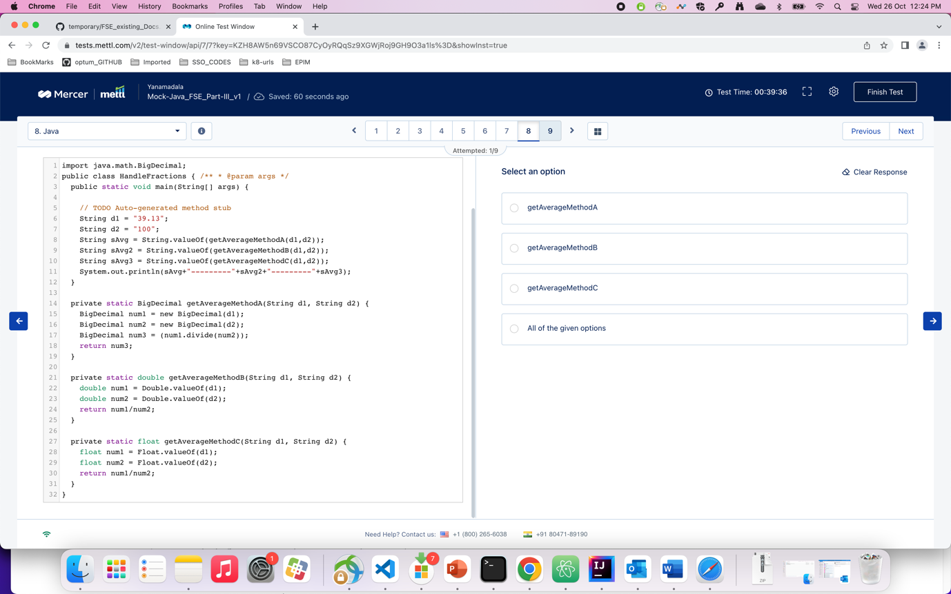

Q) how can you achieve serialization via HTTP by using spring in java programming spring

A) 3

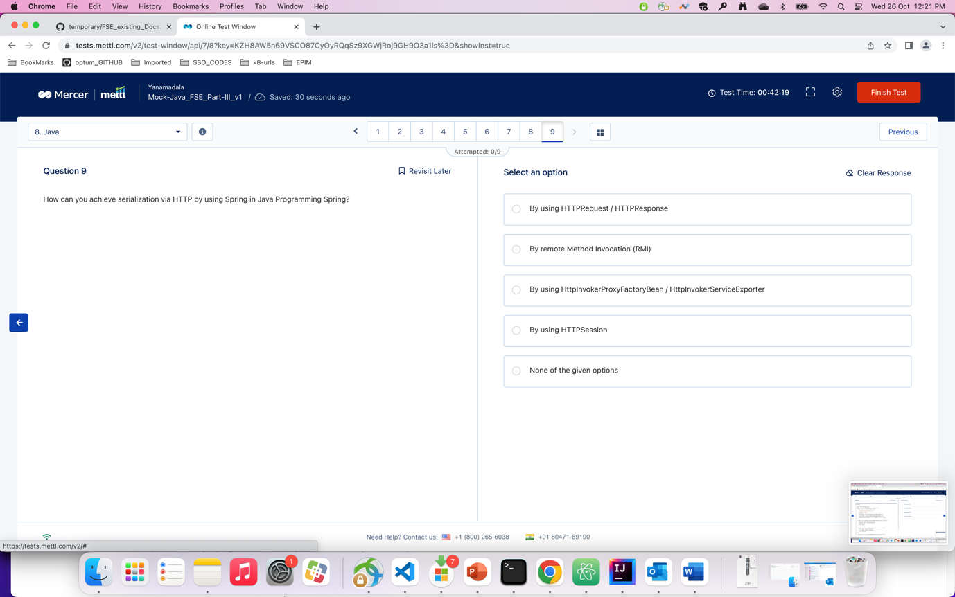

# Part-3 - satti shared screenshorts

Q) which of the following statements is/are correct about referring ….

A). 4

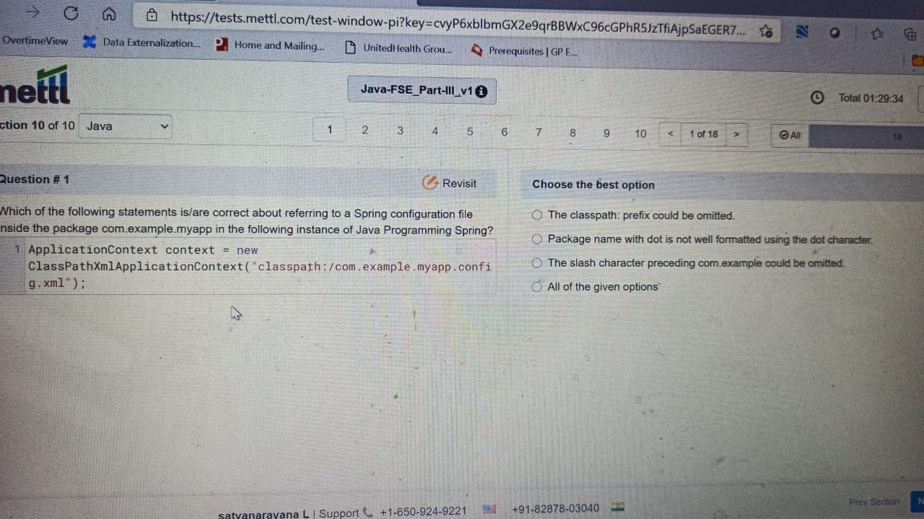

Q) which of the following options will you use to complete the given code ?

A). 3

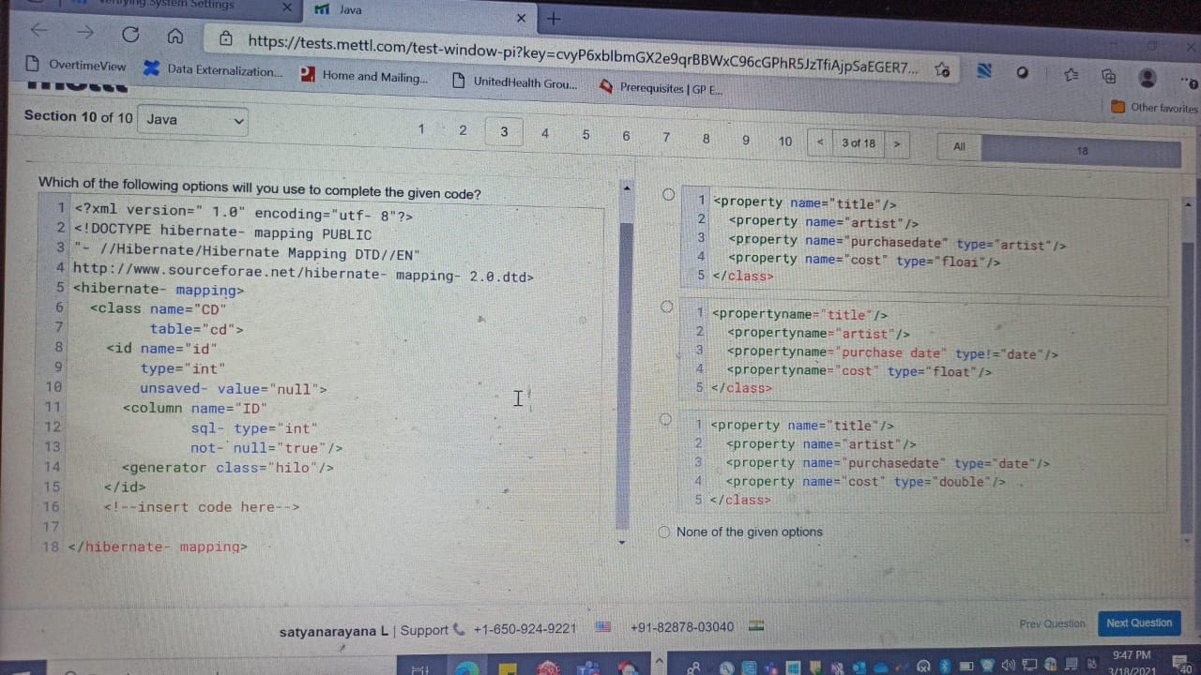

Q) the snippet given below is an example of a pom.xml for an archetype artifact….

A) 1

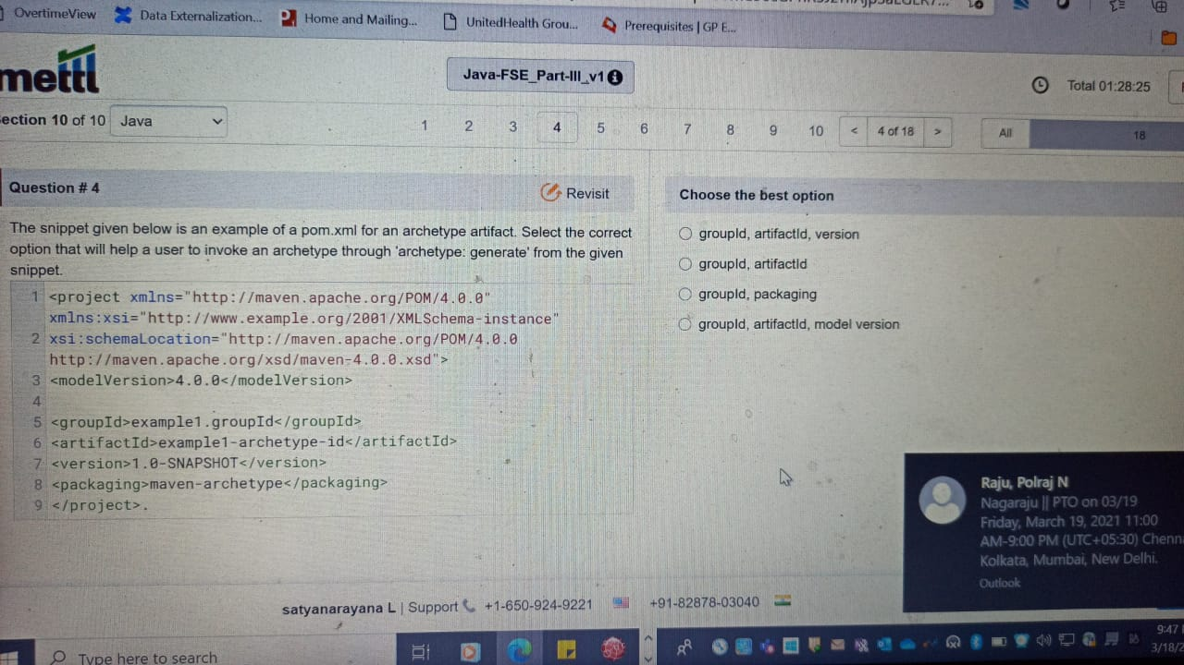

Q) what will be the output of the following code snippet ?

A) 1

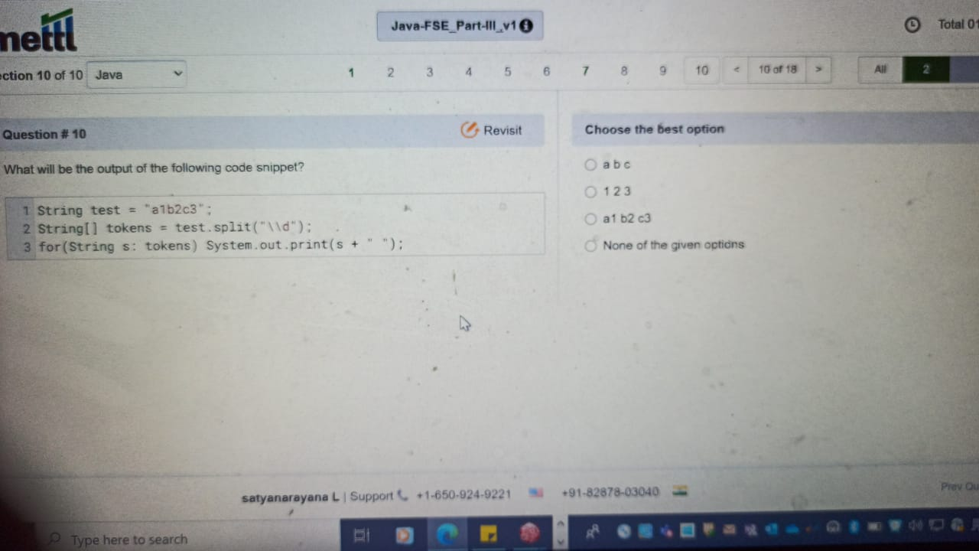

Q) what will be the output of the following code snippet ?

A) 1

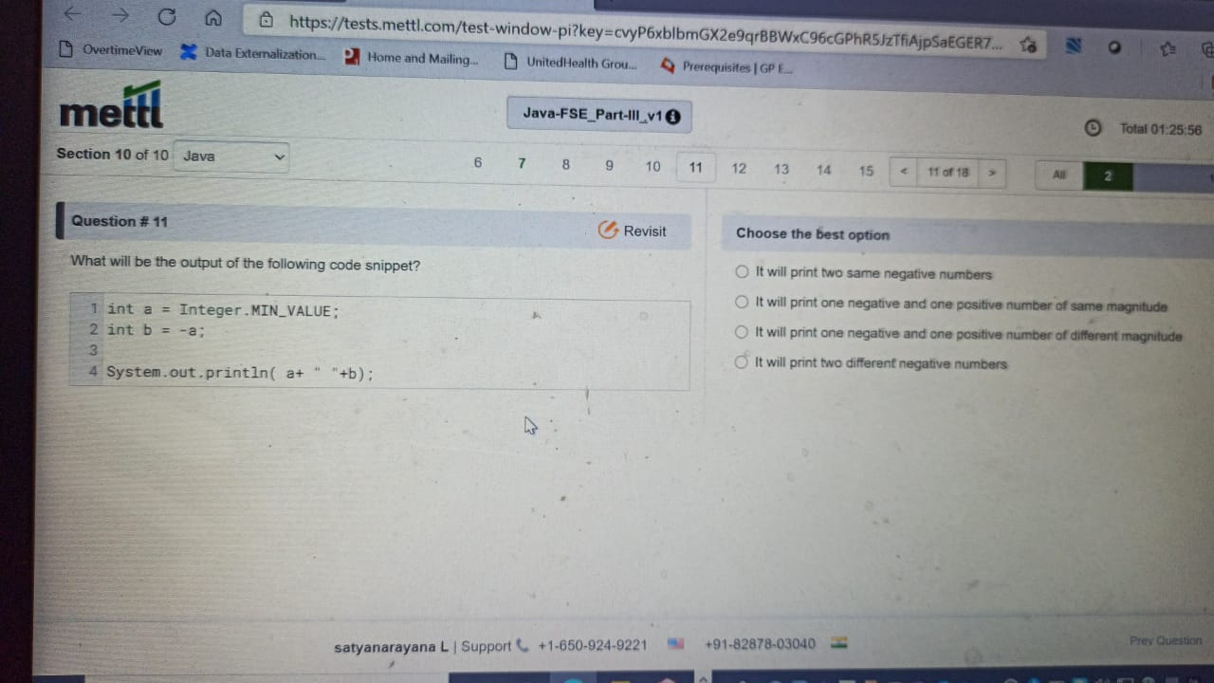

Q) what is the output … Test2

A) 4

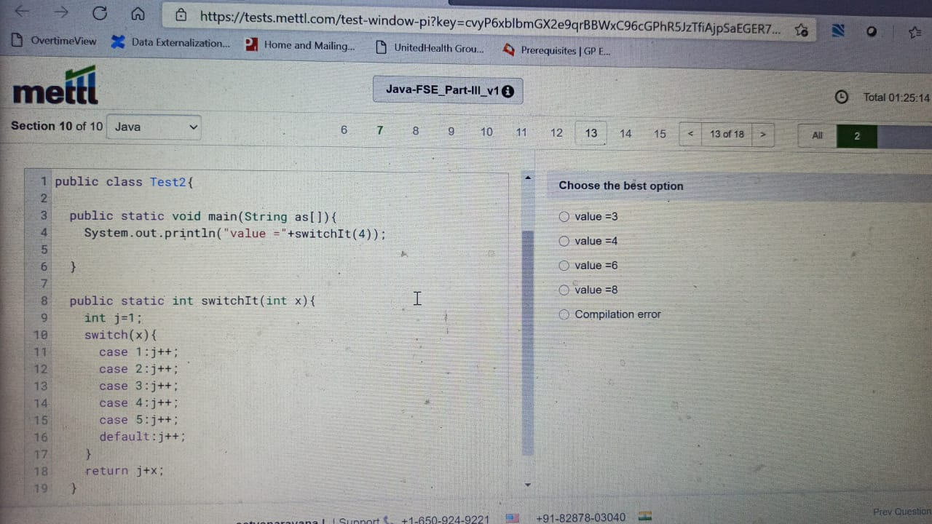

Q) which of the following statements about the mvn clean install command is/are true ?

A) 1

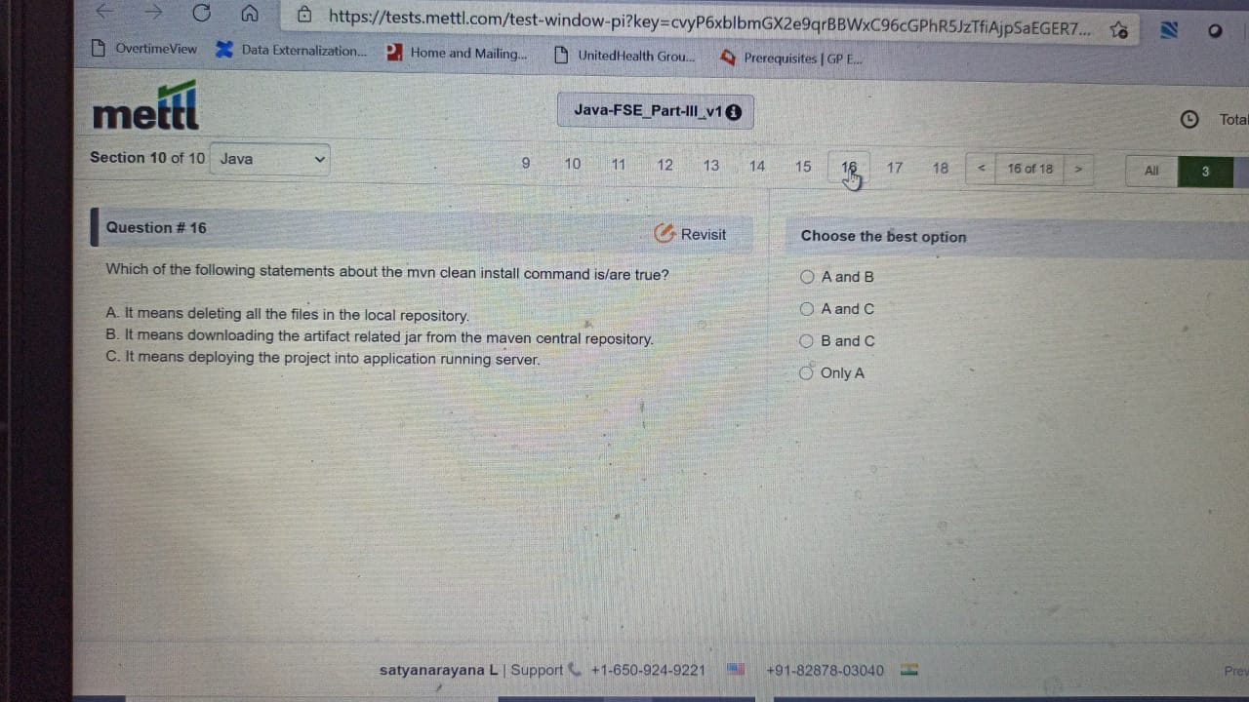

Q) Answer the following questions based on the given code snippet: …

A) 2

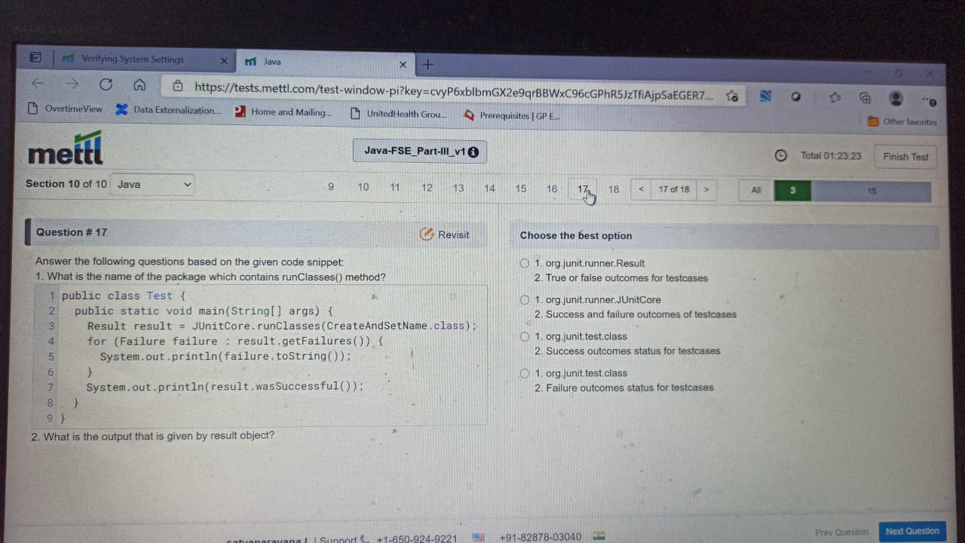

Q) A Docker container was created with option ‘—restart always’…

A) 2. ( approx. ans )

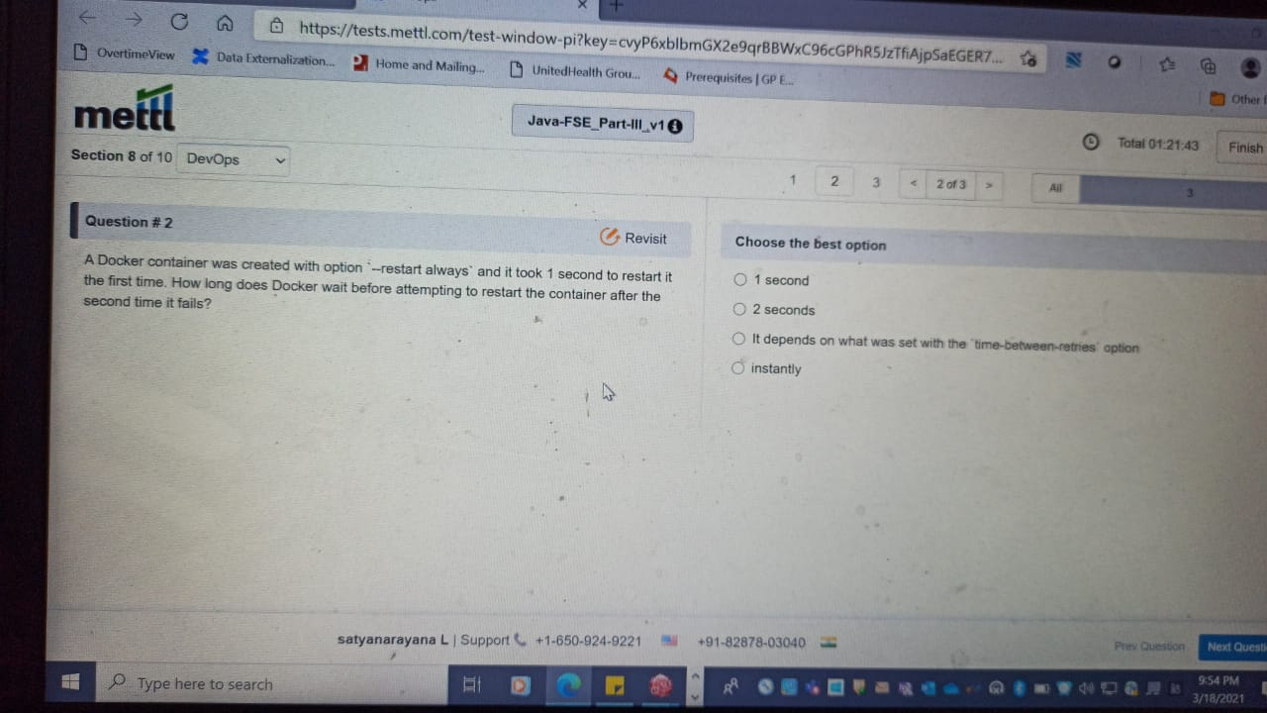

Q) what is the purpose of the below command ?

A). 4.

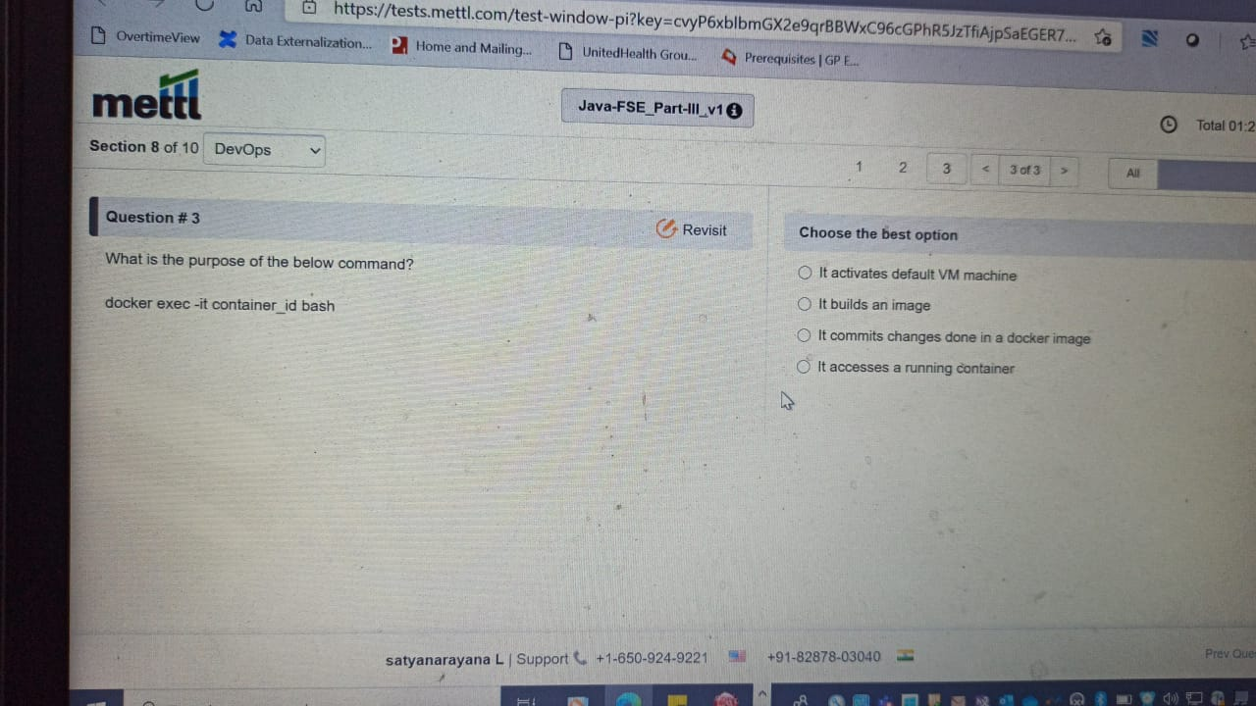

Q) which of the following actions can be completed when the BizTalk service is in ‘Stopped’ stage ?

A). 2 ? (not sure)

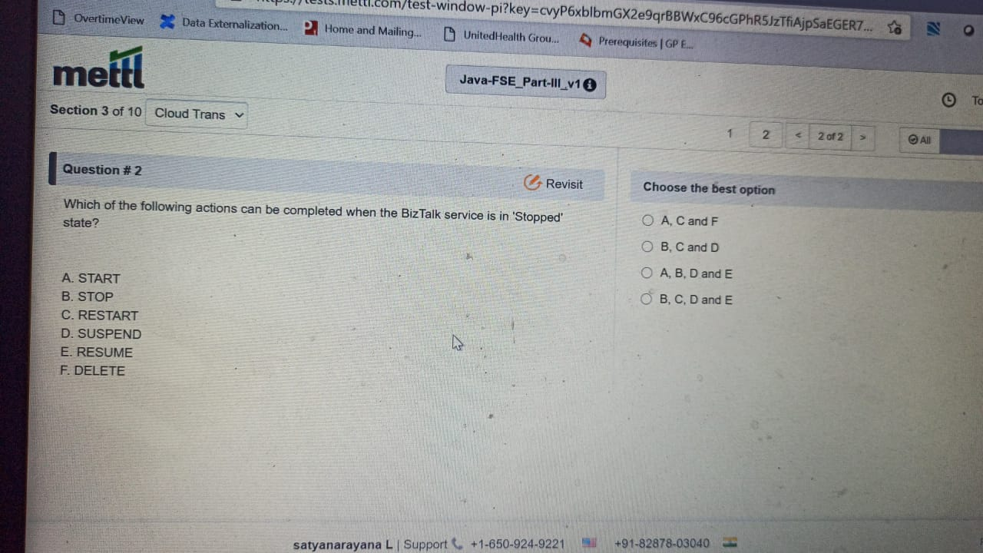

Q) you want to know whether a service is available in service registry or not. Which of the following pattern will be helpful in this case ?

A) 4

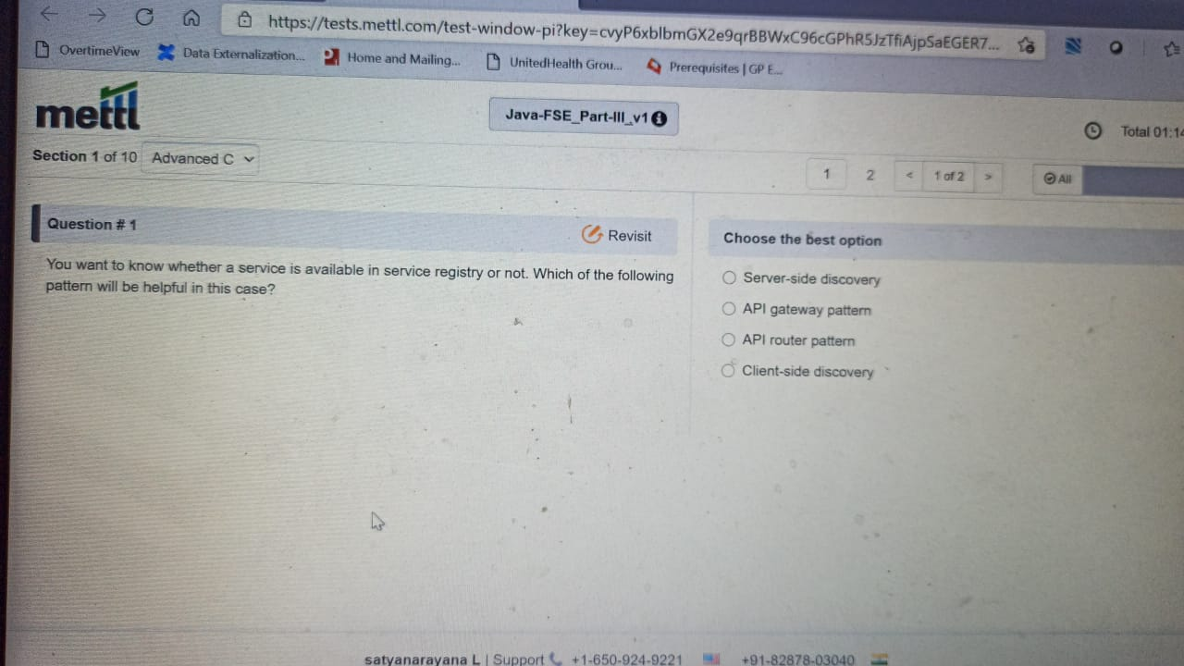

Q) An application that uses kafka is up and running with the following shortComings:

A). 1. Or 4

<https://stackoverflow.com/questions/49649241/apache-kafka-batch-size-vs-buffer-memory>

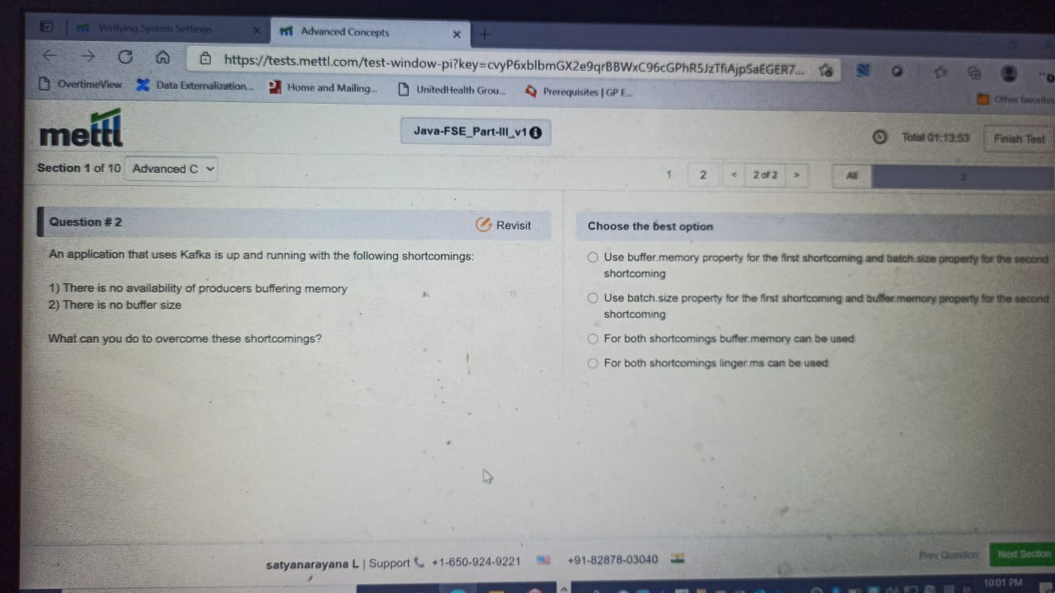

Q) which of the following functions can be performed by service agents ?

A) 4

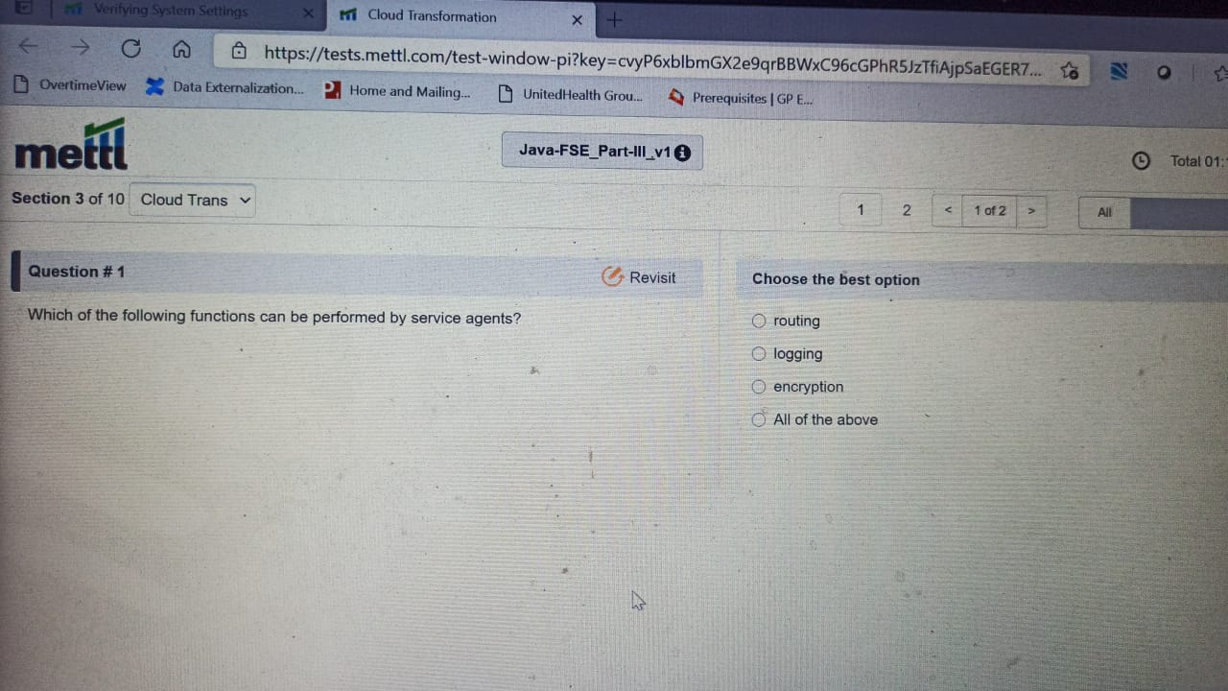

Q) 1

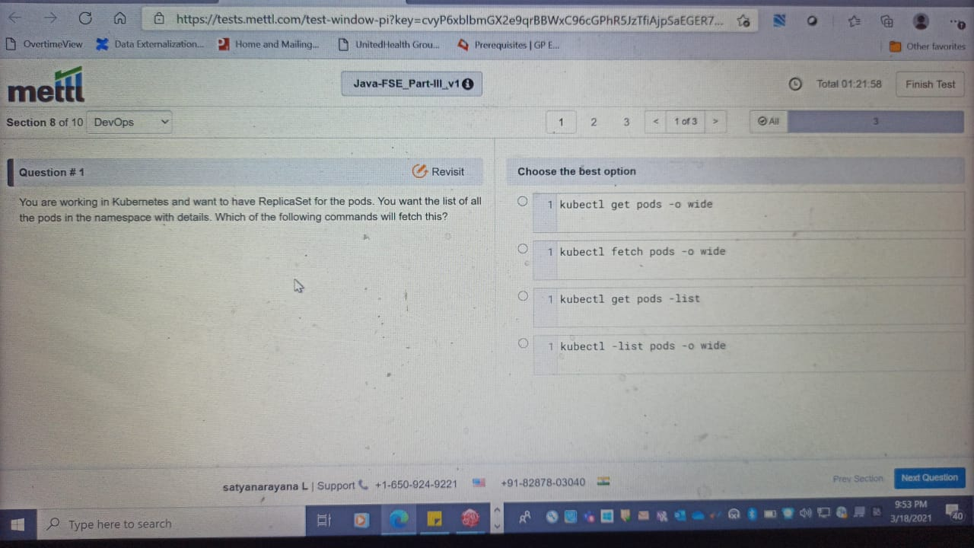

Q) which of the following annotations supports the automatic conversion of exceptions from one type to another in java spring?

A)4

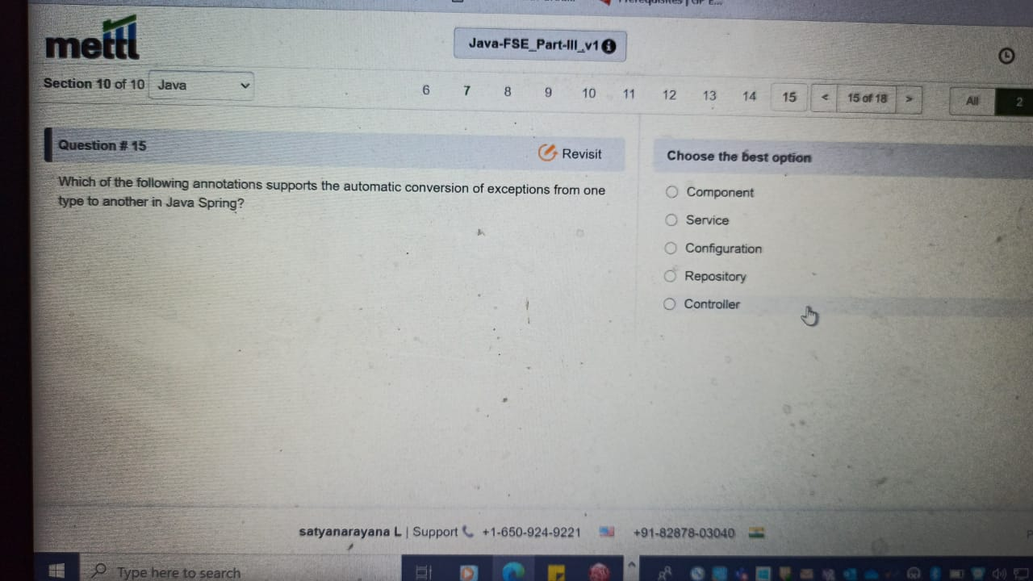

Q) what will be the output of the following code snippet ?

A) 5

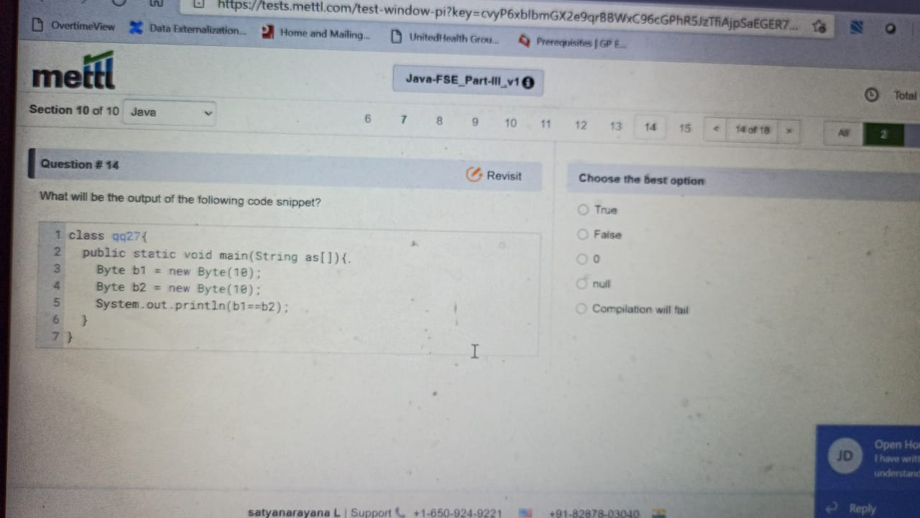

Q) what will be the output of the following code snippet ?

A) 2

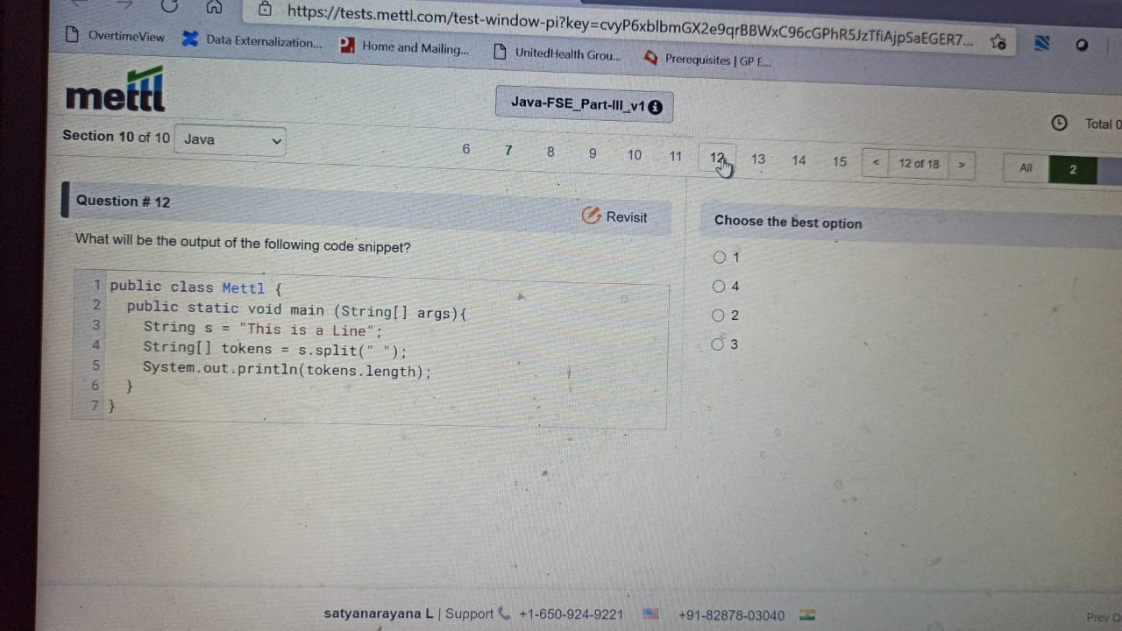

Q) considering that the memory required for JVM has been increased such…

A) 4

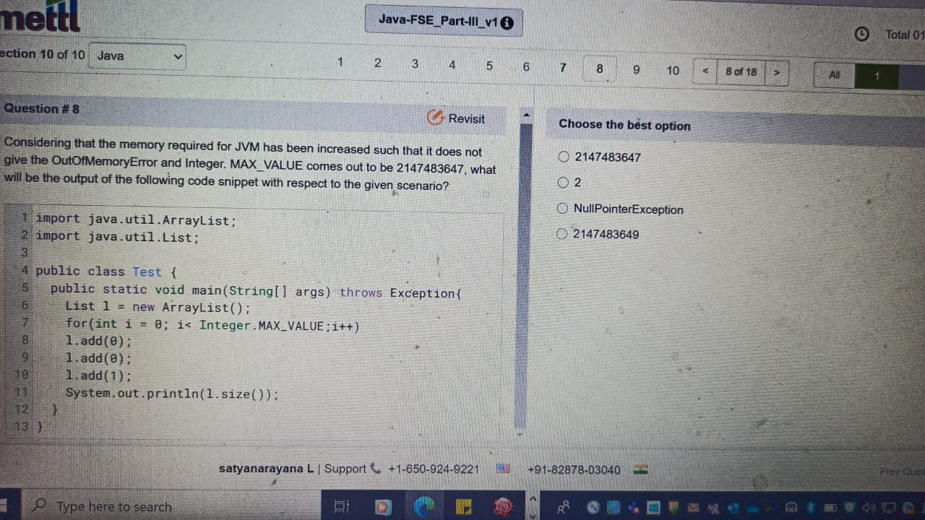

Q) which command is used to find out which POM has transitive dependency missing?

A) 2.

